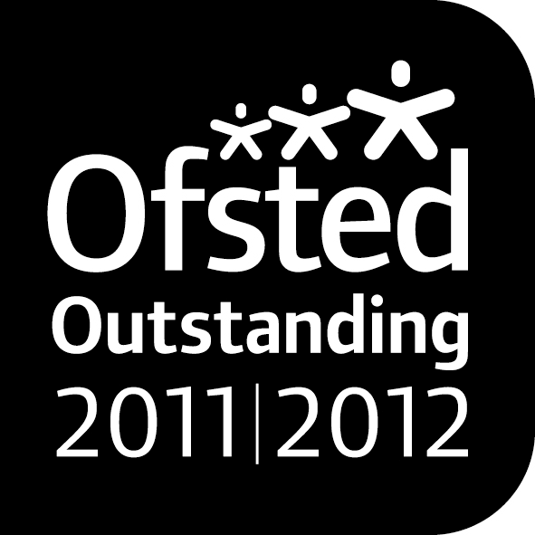

[](https://www.google.co.uk/search?biw=1366&bih=673&tbm=isch&q=easter+eggs+clip+art&revid=1526858004)***Noah’s Ark Newsletter 25th March 2014***

Dear Parents,

We are nearing the end of the Spring term and Friday, 4th April will be our last day. We still have many activities planned for the children and they can look forward to our traditional Easter egg hunt on the last day.

During our “People who help us topic” we had a visit from the police (four officers and a police car), arranged by Ella’s dad in the morning session. He will also visit the afternoon session this week. The children were absolutely delighted to be able to sit in a real police car that had flashing lights, a siren and a microphone! Thank you for this brilliant experience.

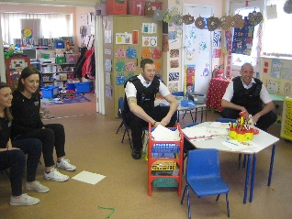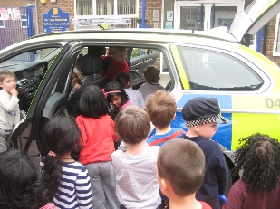

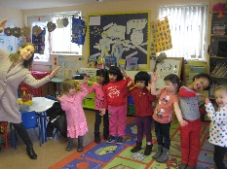Elizabeth Casella’s mum visited on Friday and taught the morning children ballet moves from the play ‘Pinocchio’. This was a fantastic opportunity for boys and girls to be involved in a dance. She will visit again in the next two weeks to continue with their practice.

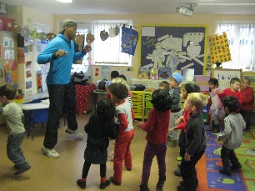Naomi’s dad in the morning session visited us today and taught the children some Zumba moves. The children and staff really enjoyed some very energetic moves!!

Thank you to all of the parents who gave up their time to share their skills and professions with the children.

If any of the afternoon parents would like to come in and share their profession (for example a nurse) or a skill (baking etc) with the children, please talk to the staff and arrange a suitable date and time. Also, if you have a baby, please come in for register time and talk to the children about how to look after a baby.

This week’s topic will concentrate on road safety including a short practice crossing the traffic lights opposite the church. Please support this topic by talking to your children how important it is to hold hands when crossing the road, looking left and right and waiting for the green man.

***Events***

Coffee morning and afternoon **– *Wednesday 2nd April*** – 11am morning session and 2.30pm afternoon session. Please join the children, who will be baking for this event to raise money for the Parish Lenten project. Canon Anthony or Father Tom may attend both events.

Easter Egg hunt – ***Friday 4th April*** - the children will be visited by the Easter bunny on this day and search for Easter eggs in the garden or indoors. To support the purchase of chocolate eggs please would you donate £1

End of term – ***4th April at 2.15pm***. The pre-school re-opens on 22nd April 2014

***Fundraising***

The family disco was very well attended and all had a good time. It was also a fundraising success ***with £550.*** The recent cake sale made ***£100***, but this will be donated to the Parish Lenton project. These are brilliant fundraising efforts and the total amount raised has well exceeded our target of ***£1500****.*

We have now been able to order a *new children’s house including a kitchen*, *replacements for our broken caterpillar*, *an open children’s house that can be used as a children’s meeting point, workshop and storage area*. We have already received *new furniture* which has self help drawers for children to select resources or games.

This has only been made possible with your generosity and the support of the Committee and Friends of Noah’s Ark. We are absolutely delighted that our present children will benefit from all our fundraising effort. ☺☺

***Library***

The library will take a break over the Easter holidays and will restart on Wednesday 23rd April. Please return your child’s library book for next week.

[](https://www.google.co.uk/search?biw=1366&bih=673&tbm=isch&q=easter+eggs+clip+art&revid=1526858004)Many thanks for reading our news. Have a lovely Easter Holiday and we all look forward to seeing you on the 22nd April.

Bettina Campion and Staff