

***Noah’s Ark Newsletter 20th May 2014***

Dear Parents,

The highlight of last week was the arrival of the chicks. All of the 10 eggs hatched with four beautiful girls and six handsome boys. This week the children are learning to handle chicks and look after them properly such as feeding, watering and cleaning. Other activities include drawing, comparing sizes, counting etc. We apply a strict hygiene routine with thorough hand washing after touching the chicks and the equipment. Unfortunately, the chicks will leave us on Friday.

The children are absolutely delighted with the chicks as the below photos show!

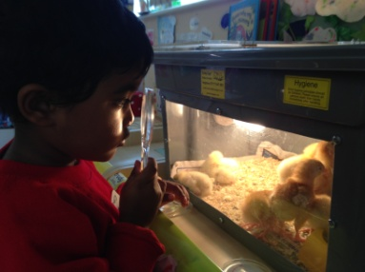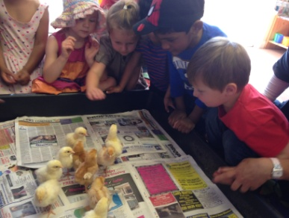

And this is how the children enjoy their new play equipment.

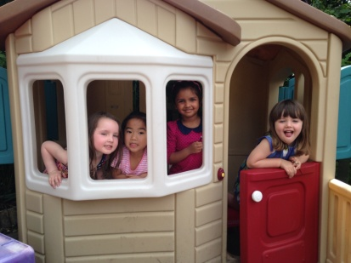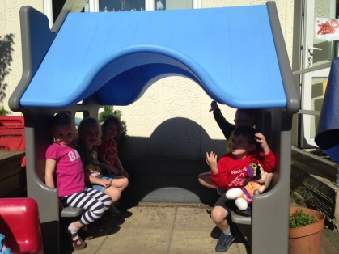

The blue house doubles up as a bus stop and the play house always attract a lot of ‘building work’ and cooking. It is remarkable how children like to copy the things they experience outside the pre-school and at home.

***Special Thanks***

Our special thanks go to Anetta (Klara’s Mum) and Victoria (Elizabeth’s Mum) who helped to make the garden look pretty by planting flowers and doing a general clean up. The children were very busy today watering all flowers. We also have been given tomato plants by Dawn and hope that we will harvest them before the summer term ends.

Also many thanks to Rafal (Kacper’s and Jakub’s Dad) who put up our notice board outside one early morning.

***Special Activities and dates***

**23rd May –** last day of half term – pre-school re-opens 2nd June.

**11th June** – The London Fire brigade will visit at 11.00am. Afternoon children can join with their parents

**20th June -** Sports day – Parents are invited to watch their children perform an obstacle course during our sports week. Parents can join at 11am in the morning session and 2.30pm in the afternoon session

**27th June –** Kingston museum will visit our pre-school in the morning and in the afternoon for a story, workshop and a dance.

**18th July –** Last day of term and Celebration event – details nearer the time.

***Forthcoming events***

*Save the date!*  
Noah's Ark BBQ, Saturday **5th July 2014, 1pm-4pm**  
Lots of fun for the family  
Details to follow soon  
   
Gas BBQs Required for 5th July 2014  
Our BBQ is a good fundraiser for Noah's Ark and its children but without something to cook on, there won't be a BBQ!!   We need to borrow 2 gas BBQs.  Do you have one to lend us?  It is all for a very good cause!  
Please email Dawn Lloyd (Committee Secretary) on [dawnharris2@hotmail.com](mailto:dawnharris2@hotmail.com)   Thank you.

***Website***

We are experiencing a few problems with our website, whilst it is still accessible for all other information we have been unable to update our gallery with pictures from recent events. As a result the gallery will have to be revamped and this will take a few weeks. As soon as it is up and running we will let you know.

***Summer Weather***

We are all enjoying the warm weather. Although we have plenty of shading in the pre-school’s playground please make sure that your child arrives with sun cream applied. We have sun hats available at pre-school, but not for the whole class. Try not to let children wear flip flops as these offer no protection as they are hazardous. The children have plenty of water available and whilst it is warm we will try to have snack time outside in the shade. There might also be the occasional offer of an ice cream!

Many thanks for reading our news. Have a relaxing week off.

Bettina Campion and Staff