

**Noah’s Ark Newsletter December 2019**

Dear Parents,

Christmas is just around the corner and the children are busy with festive activities as well as practising for their play and sing-along on **Tuesday 17th December**. They are all excited to see their parents on this day. The performance will take about 20 minutes and starts at **9.45am** for the morning and all day children. For the younger children in the afternoon, we are offering a Christmas sing-along at **2.30pm**. For both performances please arrive promptly. The day will finish at **2.45pm** for the last day of term.

Our Christmas tree competition is coming to an end and if your child still has theirs at home, please bring it in along with his/her sponsor money. The winners will be announced on Monday **16th December**. The money raised for this event will be used towards new resources for the children.

For the Christmas parties on Monday 16th, we will provide party food for the children. The children will experience the normal routines with party music and games. Please allow your child to wear party clothes or a Christmas jumper. There will also be a visit from Santa (**Psst!**) in the morning and afternoon.

We have had a busy term and hope that your children are all settled now and happy to come to Noah’s Ark.

Please see a selection of photos from our daily routines.

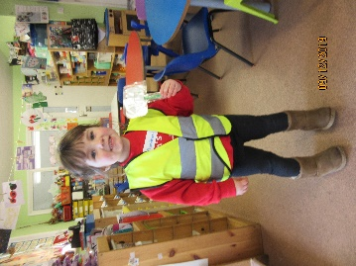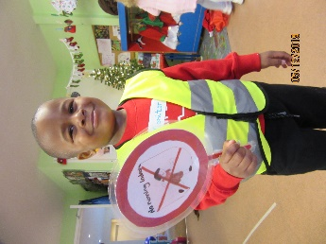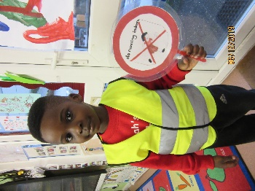

David, Mcdavid and Sophia are helping with the daily routines and rules.

Each day we will select a different child!

***Christmas Cake Sale***

A huge thanks to Rachel and her many helpers for this event. The cake sale made about £125 which is a super result. The weather was truly atrocious and we are very grateful that you still went ahead with the sale. Also, many thanks to all parents who baked some fantastic cupcakes and bought cupcakes too on this day. **☺☺☺**

***Pyjama day***

We have raised £29 for this occasion and will put the money towards a new stereo equipment. We took a number of pictures, but felt that these weren’t suitable to publish on the website. We will use them for the Learning Journeys instead.

***New Committee***

We welcome our new Committee with Jo Oakley as Chairperson, Chaminda Karunaratne (Chanuli’s dad) as Treasurer, Tara Kenny (Erin’s mum) as Secretary, Lucinda Walsh, Lana Holmes (Jasmines’ mum), Suman Puveneswaran (Anith’s dad) and Elisa Goldsbrough (Harry’s mum) as Committee members. The AGM minutes will be available in the New Year.

***Library***

The children’s library finished last week. Please return any books that you still have at home. We will restart the library in the New Year.

***Funded children and 30 hour code***

If you have a 30 hour code, please ensure that you update it in line with HMRC guidelines. And if you are new to 30 hours, please ensure that you have activated it well before the year ends. All funded children will receive their funding declarations in the 2nd week of January 20 for signature. If you have changed your child’s hours you will be given a new form.

***Dates***

**Christmas Parties**  – 16th December am and pm session

**Christmas Play** – 17th for morning/all day children only at 9.45am

Sing-a-long – at 2.30 for afternoon children

**Last day of term - 17th December** – we finish at 2.45am

**Noah’s Ark reopens** - 6th January 2019



Wishing you a very peaceful Christmas and a happy New Year.



Bettina, Theresa, Sandie, Sharna, Rosy, Nevila, Rosy, Lisa, Latoya and Dawn