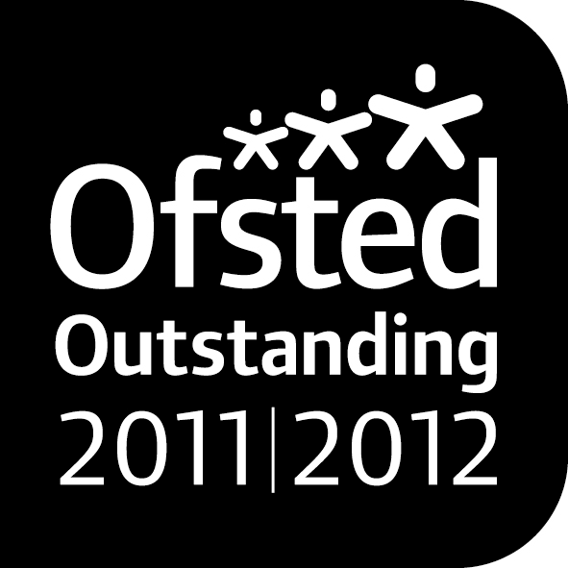

**Noah’s Ark Newsletter February 2018**

Dear Parents,

Half term is nearing and there are still two important events to attend. The children are preparing for the coffee morning this week. As in recent coffee mornings, the children are taking ownership of the event by selling their products (decorated cakes) to you. Please come and support this event.

Our topics for next half term will be *Numbers; Spring themes, Natural world including animals and plants.* Our topics are based around children’s interests and new experiences.

We are very grateful for all your fundraising efforts and below is a selection of purchases made with these. The new caterpillar came in fabulous colours!

Please also see a selection of the children’s dressing up day.

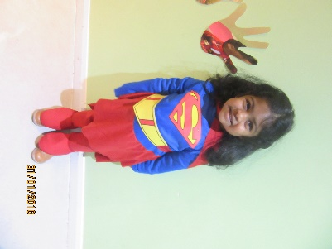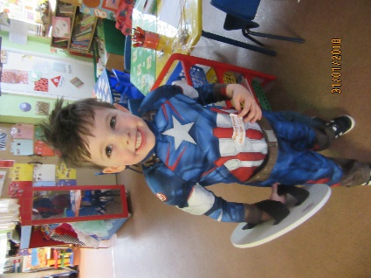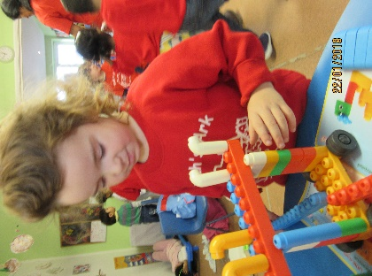

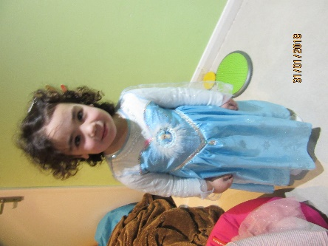

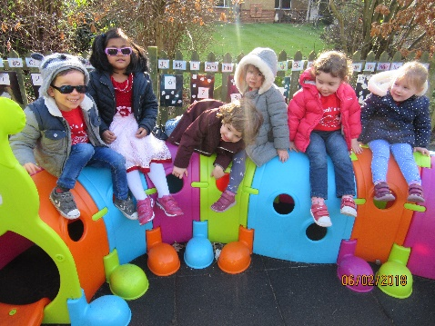

***Disco***

The disco is the second biggest event organised by the Committee and Friends of Noah’s Ark. Please support this event on Saturday, 10th February, in great numbers. Tickets can still be bought. If you have lost your ticket requests, please ask any staff member to give you another copy.

***Food Hygiene Rating***

We are very pleased to announce that following yesterday’s Kingston Council’s Food and Safety inspection, we received the highest rating with 5 points. They inspected cleanliness of the kitchen area, the fridge, daily checking procedures, and policies consisting of three separate documents as well as allergy safety.

Well done to all staff members for keeping Noah’s Ark tidy, safe and hygienic!! ☺☺☺

***Parental partnership***

Please do let us know if you are having problems at home with regard to your child not sleeping, eating or behaving. We are here to help and can work out strategies together.

***Additional sessions after Easter***

If your child is presently attending a few sessions in the afternoon and you would like to increase after Easter, please inform us as soon as possible. As the spaces left are extremely limited, we can only allocate them on a first come first serve basis.

***Learning Opportunities***

As promised in our last newsletter, we have produced a small booklet for learning opportunities at home. This booklet will be sent home this week. We hope that it may prove useful for you and explain the learning areas in more detail. If you have a learning opportunity that works particularly well and interests the children, please share them with us!

***Dates***

**Coffee morning and afternoon** – 9th February 2018, 11am for morning parents and 2.30 for afternoon parents. Parents of all day children can join any of the two sessions.

**Noah’s Ark Family Disco** – 10th February 2018. Please keep your diary free and join this super family event organised by the Friends of Noah’s Ark and Committee Members. Further details to follow.

**Half term** – 12th until 16th February 2018

**Visit to Rosclare Old People’s home** – 27th February 2018

**Parent consultation meeting** – 6th and 7th March 2018

Thank you for reading our news.

Bettina Campion

Pre-school Manager