

**Noah’s Ark Newsletter January 2018**

Dear Parents,

A Happy New Year 2018 to all of you and a very warm welcome to the new children and parents who joined us this term.

*We would like to thank you for your many presents and cards for Christmas. It was so generous of you and much appreciated by us!*

This term we are planning activities for the following topics Winter themes, feelings, senses, winter stories and healthy lifestyles. For some of these activities the children may be asked to bring in things from home, e.g. a piece of fruit for a fruit salad. We will, of course, send you little reminders via your child’s bookbag.

There are lots of events and activities to look forward to. For example, we are also planning another visit to Rosclare’s Old People’s home with another set of children this half term and we may receive a visit from the fire brigade and the police depending on their availability. Next week, we will be walking along the Broadway in small groups to look at signs and numbers in the near environment.

Please see below a photo from our morning Christmas play and afternoon children’s visit to the crib in church.

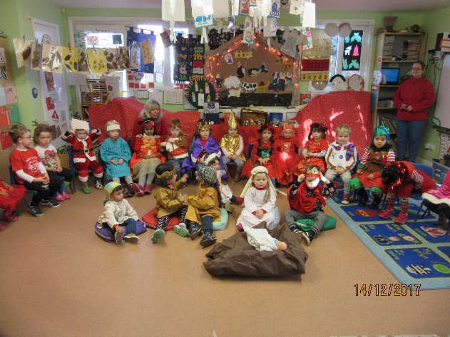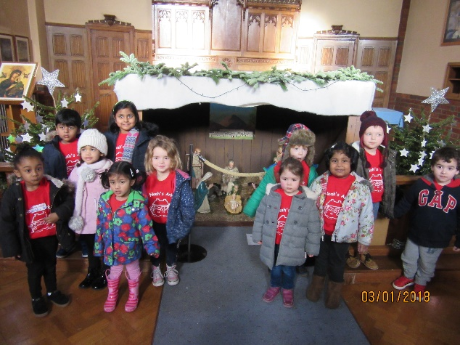

***Library***

The library returns tomorrow. Books are lent for a week and then need to be returned in order to receive a new one.

***A few reminders***

Please arrive on time when collecting. Some children get quite upset when they are collected late. If you are late, please phone us, so we can tell your child. If your child is ill, please let us know so we can mark your child in as explained. We are still expecting many children to become ill with winter illnesses. Remember, if they have a fever, infectious disease or vomiting and diarrhoea they will need to stay at home at least 48 hours after the first symptoms appear.

If you haven’t applied for your child’s reception class place, please note the deadline is the **15th January** **2018**.

***School fees***

When paying school fees, please would parents reference their child’s name on the bank transfer. Many thanks.

***Learning Opportunities***

This term we will be concentrating on letters and sounds and number recognition. We start this off with a walk to Tolworth Broadway. To support this learning opportunity, why not talk to your children about numbers and print in the environment when walking to pre-school, e.g. look at bus or house numbers. Other learning opportunities will be compiled for you in a small booklet in due course.

***Dates***

**Walk to Tolworth Broadway –** 17th January 2018

**Dress up as Superhero or Princess Day** – 31st January 2018

**Coffee morning and afternoon** – 9th February 2018

**Noah’s Ark Family Disco** – 10th February 2018. Please keep your diary free and join this super family event organised by the Friends of Noah’s Ark and Committee Members. Further details to follow.

**Half term** – 12th until 16th February 2018

**Parent consultation meeting** – 6th and 7th March 2018

Thank you for reading our news.

Bettina Campion

Pre-school Manager