

**Noah’s Ark Newsletter January 2019**

*Dear Parents*,

We hope you and your children have all settled back well into the new term. Thank you again for all the very thoughtful presents and cards we received from you for Christmas. We are still enjoying the various chocolates and biscuits for our lunchtime treat.☺

Our topics for this term are ‘*Transport and Road safety*; *My Science*; *Natural World & Growth*; *Winter themes* and *Healthy Me continued.* As always, we will keep it flexible as some topics may not fit in with the children’s interest or the weather. As always, the team are planning exciting activities which will include outside walks as well as celebrating upcoming events such as Chinese New Year or Valentine’s Day.

We are presently preparing the children for road safety and have sent home a book from Transport for London. Please see below how we incorporate road safety in our daily activities.

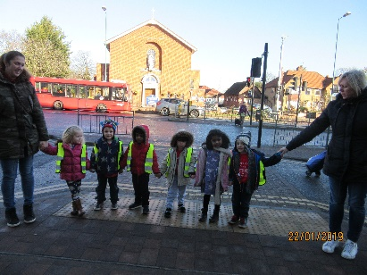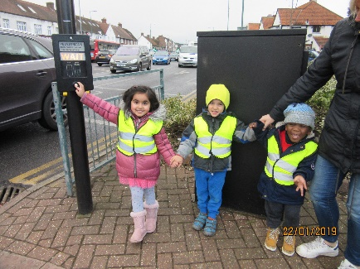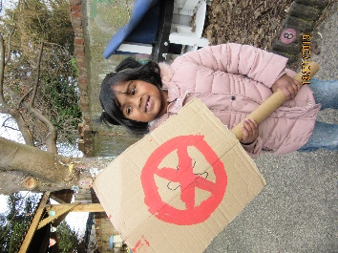

Last week’s lunch time award for healthiest lunch box goes to Patrizia Dalgilis. Her lunch included lots of healthy food including salmon which she says was ‘yummy’. ☺☺☺

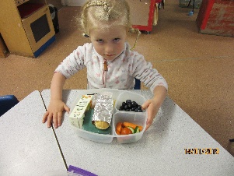

Please may we remind you that we are a ***‘nut free’*** pre-school and ask you not to give children peanut butter or Nutella on their sandwiches as well as other nut containing products. We very much appreciate your cooperation in this matter.

***Toilet training***

With half term fast approaching, we would urge parents to have another go at toilet training their children. This would also include handwashing routines. Whilst many children are out of nappies some do not yet know how to wipe their bottoms properly. If you need any tips, please speak to any member of staff.

***Termly Contribution***

Thank you so much for all the parents who have already paid our termly contribution, however there are still quite a few outstanding. We will try and incorporate these in next term’s invoices/free funding notices so that you do not receive too much paperwork from us.

***Show and Tell***

We would encourage parents not to allow children to bring toys from home, but only for our dedicated show and tell activities. Unfortunately, their toys can get lost or cause children to fight over them which can be upsetting.

***Illness at pre-school***

If your child becomes ill at pre-school, we will contact you as soon as possible. Unfortunately, due to the size of our pre-school there is no dedicated room where we can safely separate unwell children from the rest of the group. We also do not give Calpol to children as we do not store this at Noah’s Ark. Any medication to be given to children needs prior consent and has to be brought from home. If your child needs Calpol he/she is clearly not well enough to be at Noah’s Ark.

***Dealing with concerns***

We would always hope that you are happy with our service and how we are dealing with issues. If there are any concerns regarding your child or the setting, please come and speak to us first. We are happy to listen to any issues or worries you may have and will try our utmost to find amicable solutions.

***No Mobile phones***

It is a requirement for staff to remove their mobiles during sessions. This also applies to parents and visitors of the pre-school. Please abstain from using your phone whilst in the pre-school. It would be considered a breach of our safeguarding policies should this be seen by an Ofsted inspector. I very much appreciate your understanding for this reminder.

***Clothes labelling***

Please label your child’s/ren’s clothes with their name. There are quite a few children with similar coats not to mention the Noah’s Ark jumpers. Many thanks.

***Dates***

**Dress in your favourite costume day** – 13th February

**Half term holiday** -18th February – 22nd February

**Family Disco** – 23rd February. Keep your diary free for this fantastic family event

**Parents Consultation meetings** – 5th March 3.30pm – 4.30pm

**Parents Consultation meetings** – 6th March 3.30pm – 4.30pm.

**Cake sale** – 8th March after school

**Coffee morning and afternoon** – 28th March

**Last day of Spring term - 5th April**

Thank you for reading our news.

Bettina Campion

Pre-school Manager