

**Noah’s Ark Newsletter May 2019**

*Dear Parents*,

We are in full swing of the first half of the summer term. There are lots of exciting things planned by the team with the Living Eggs (hatching chicks) arriving soon.

The topics this term are ‘Mini beasts’, ‘Natural World including plants’, ‘Active me’ and ‘Sight & Sound’. For the topic ‘Mini Beasts’ we have received a donation of a live butterfly garden kit from Harriet’s mum (morning session). The children will be learning how caterpillars develop into butterflies. This will be a lovely activity for them as they will release them into the pre-school’s garden when it’s warm enough.

Please see below a selection of recent activities at Noah’s Ark.

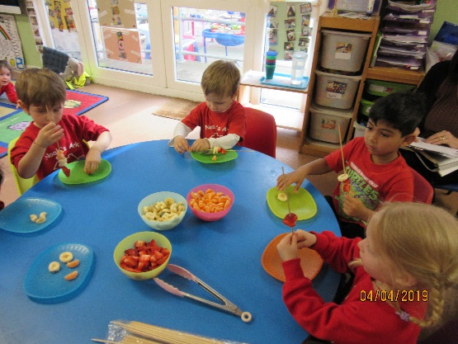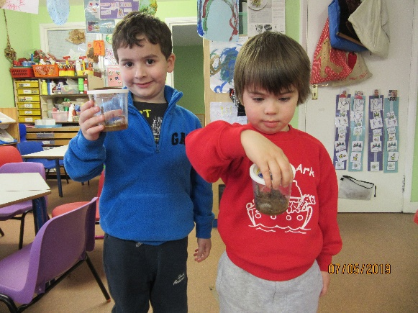

James and Archie with caterpillars Making healthy fruit kebabs

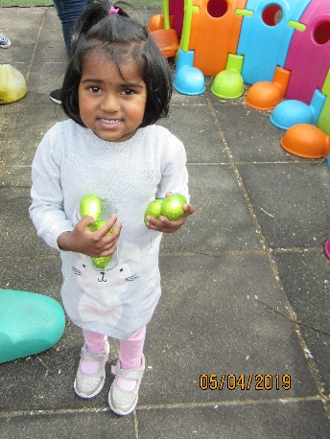

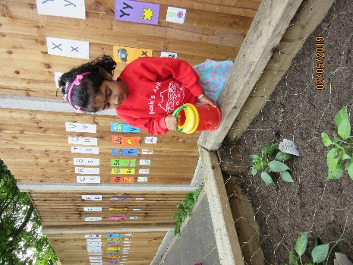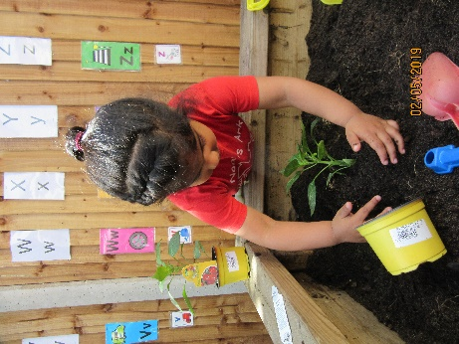

Keira planting a pepper plant Ann watering our new plants Rose’s Easter eggs

***Staff News***

It is with much regret to announce that Julie will be leaving us at the end of half term. Julie has been with us for almost 10 years and we will be very sad to see her go. She will be taking up a new position in the NHS for which we wish her the best of luck!

***Toys brought from home***

We are encouraging parents to avoid allowing their children to bring toys from home unless it is for a special show and tell activity. We recognise that children can get very anxious when their toys are lost or their friends are trying to play with them. It is also very difficult for staff to retrieve them as they tend to be small. Please talk to your children about this and we will do the same at register time.

***Dog Safety Awareness***

We have two children who are very anxious about dogs. We have contacted a trained dog handler who will be coming to Noah’s Ark to talk to the children and bring a dog as well. They will learn how to safely approach dogs when they encounter them outside their home. I will let parents know when this is going to happen.

***Dates***

**Living Eggs –** will be delivered on 13th May, chicks return to farm on 24th May

**Half term -** 27.05 – 31.05.19

**Noah’s Ark returns –** 3rd June

**Sports Day –** 24th May parents attend at 11am for morning children and 2.30pm for afternoon children. Parents whose children attend all day on that day may attend either timings. If the weather is very wet we may have to postpone on short notice.

**Last cake sale of the academic year** – 21st June

**Last day of the academic term**: Friday 19th July.

Thank you for reading our news.

Bettina