Noah’s Ark Team
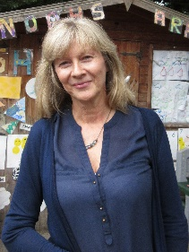
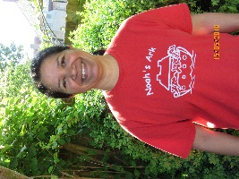

Bettina Campion Theresa D’Souza
Manager Deputy and SEND Co-ordinator

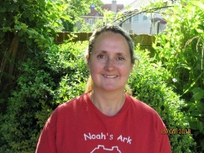
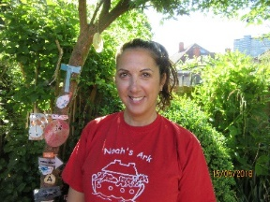

Sandi Alayli Sharna Osborne
Early Years Teacher Early Years Teacher

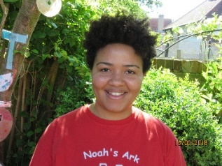

Rosy Kanyiki Nevila Mansaku
Early Years Teacher Early Years Teacher

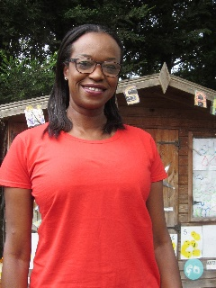
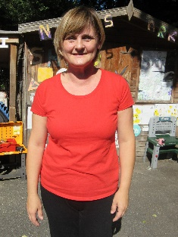

Lisa Kitchener Latoya Reisinger
Early Years Teacher Learning Support Assistant
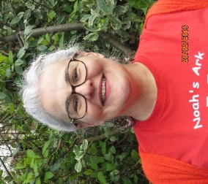
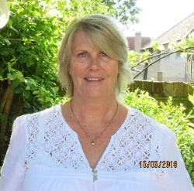

Suelli Loures Dawn Lloyd

Bank staff Finance Assistant

