

***Noah’s Ark Newsletter 9/11/15***

Dear Parents,

I would like to extend my thanks to all parents who attended our Parents Consultation Meeting. It has been a very good experience with positive feedback. If you still need an appointment please speak to your key person. Our next meeting will be held at the beginning of March 2016. Once you have received your child’s yellow Learning Journey, please update it and send it back to Noah’s Ark.

This term’s topic is “**Favourite stories including autumn themes and celebrations**.” To support our autumn topic the children will be going to the park on **Wednesday, 11th September 2015.** The children will be learning about road safety, how to adapt to different learning environments (understanding the world), answering questions (communication and language), collecting leafs of different sizes and colours to support Maths and Expressive Arts and Design. Please support this activity by accompanying us straight after register time. We will need at least 10 parent helpers in the morning and 6 in the afternoon session.

Angela Habibi (Alanah’s mum) visited on the 22nd October in the morning and talked about her job as a nurse. The children had great fun and were actively involved in her presentation. Many thanks from all of us for teaching our children something interesting.

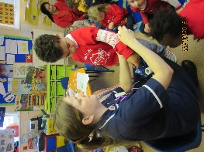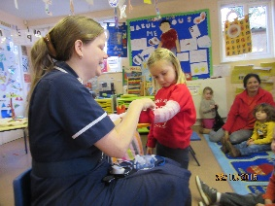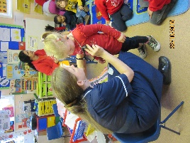

***Dates for your diary***

Autumn walk – **11th November 2015**

Cake sale – **20th November 2015 –** Please bring in your home baked or shop bought cup cakes which will be sold in the afternoon by Friends of Noah’s Ark. Any proceeds will be used towards fundraising projects.

Christmas Singing – **11th December 2015** – 11am for morning parents and 2.30pm for afternoon parents. We will send requests for costumes as soon as possible.

Last day of term – **16th December 2015 –** Both sessions will have a Christmas party amongst the normal activities of the day. Noah’s Ark reopens on 4th January 2016

***Survey***

A very short survey about the 30 hour funding will be send home in your child’s book bag this week. I would be very grateful if you could fill this form in and return it as requested. This survey will form part of Noah’s Ark’s future strategy.

***Website update***

The website has been updated with some photos from the coffee morning/afternoon and some dates. Photos from our forthcoming walk will be added as soon as possible.

***Friends of Noah's Ark Meeting***

**Can you help?**  We are looking for co-ordinators for the following Friends of Noah's Ark fundraising events: Cake Sales, Disco and BBQ.   
   
These events are vital to our fundraising!  All monies are spent on equipment, books etc for the children.  Without your help, the children will go without!  Your help would be voluntary, i.e.unpaid but it is very rewarding and a great way to meet other parents.

We will be meeting at **La Moda café  (opp. M&S) Tolworth Broadway on Thursday, 12th November 2015 at 9am**  
   
If you cannot attend the meeting but would love to help by taking charge of one of these events please let Dawn, Clerk to Committee, know  at [dawnharris2@hotmail.com](mailto:dawnharris2@hotmail.com)  
   
Thank you.

***A message from Angelina Baird***

Dear Parents and children, thank you so much for the lovely messages, flowers and gifts. It has been fun working with you all. Miss you all. Best wishes,  
Angelina

***Fundraising activities***

Every year, children of Noah’s Ark participate in their own fundraising activity with a simple sheet to decorate a Christmas tree/Santa’s sleigh with different colours or objects. In return they are asking to be sponsored by their family and friends with money. We will soon put one of these sheets in your child’s book bag. The first three best/unusual/most effort etc. in each session will win a price. All of the filled in sheets will be displayed. Please support this event.

***Contingency Plan***

There may be times when Noah’s Ark have staff absences during illness or other emergencies such as extreme weather. For this reasons we operate a contingency plan. We will always endeavour to keep the pre-school open as long as the child/adult ratio is not compromised. The plan is displayed

in the foyer.

Many thanks for reading our news.

Bettina Campion

Pre-school Manager