

***Noah’s Ark Newsletter February 2016***

Dear Parents,

I hope that all our new children have now settled in and enjoy the pre-school’s routines and activities.

It has been a busy few weeks for the children ending with Chinese New Year, Shrove Tuesday, Ash Wednesday and Valentine’s day. During this half term we have concentrated on British values such as looking after our toys, sharing with our friends, helping our friends in need, doing something special every day. To support this, children will be rewarded with stickers and this will be celebrated at the end of the session. Please talk to your children at home about helping others and ask them to do little tasks for you such as setting the table or clearing their toys away.

If you still haven’t returned our survey, please do so as soon as possible. Your comments are valued and will be used to improve our provision and I will report back in due course.

We have bought a few urgently needed new plastic tables and chairs. See below picture of children enjoying these.

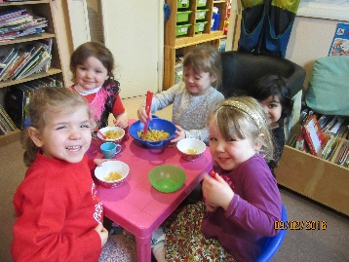

**Friends of Noah’s Ark Pre-school Disco Saturday 5th March**

Only three and a half weeks until our disco! Please return your ticket requests as soon as possible. Also, if you have any donations for the raffle please hand them in at Noah’s Ark.

**Dates**

**Half term holidays –** 15th February until 19th February

**Pyjama day** – Friday 12th February. Dress up in your favourite pyjama. Donation of £1 is requested. If your child does not attend on Fridays, he/she can wear it any other day.

**Parents Consultation Meeting** – 1st March 2016 afternoon. Please make an appointment on the sheet displayed in the foyer during the week beginning 22nd February 2016

**Disco** – 5th March 2016

**Coffee morning and afternoon –** 18th March – 11am and 2.30pm for parents.

**SAINSBURY'S ACTIVE KID VOUCHERS**

We are now collecting these vouchers from Sainsbury's.  This a great way for getting your children play equipment for the pre-school. Please ask friends and families to let you have their vouchers.The collection box is just inside the door.Thank you!

**Holidays and other absences**

If you are going on holiday, please let us know exact dates in writing. It is important for us so that we can plan activities and documentation accordingly. Absences during Census week may result in funding being withdrawn so please make sure to let us know well in advance.

Please also inform us by phone or email of other absences such as illness or appointments. Many thanks for your support in this matter.

**Fundraising news**

Our recent cake sale was a success with a great amount of baked and bought cakes. We made **£100** – a fabulous result!! Thank you to the organisers Jo and Kate and their helpers. ☺☺

Wishing you a lovely half term!

Bettina Campion

Pre-school Manager