

***Noah’s Ark Newsletter January 2017***

Dear Parents,

A very Happy New year to all of you!

The team and I would like to thank you for all the lovely cards and presents received from you. It was very generous of you and we are pleased to have lots of chocolates and biscuits for our breaks in the future. ☺☺

Our topics for this half term will be Winter Themes including stories and Senses (Taste, Smell, Sight and Sound). To support learning at home, please talk about the winter weather using words such as cold, frosty, icy, windy, cloudy, slippery.

For our topic taste, when eating at home, ask your child what their food tastes like, for example use words such as sweet, salty, bland, sour and spicy.

For our topic touch you can talk about warm and cold at bath time or rough and smooth for items such as brushes or paper.

Please see below a selection of photos during Santa’s visit on our last day.

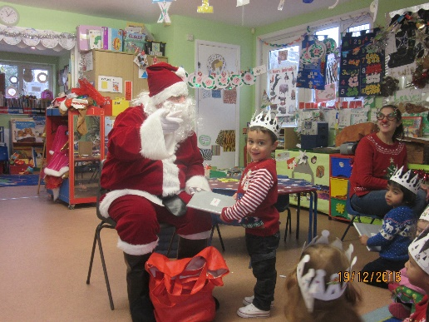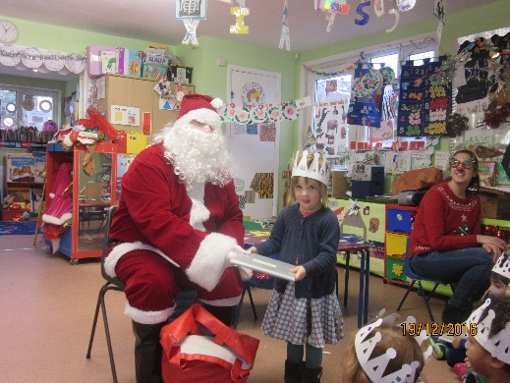

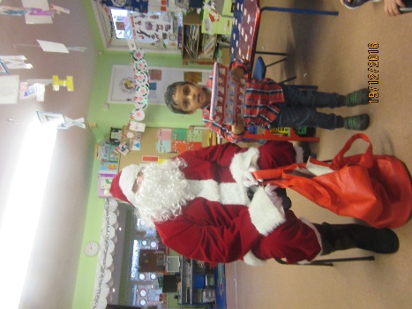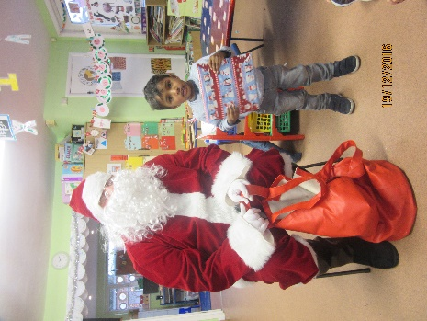

***Dates***

Half term holidays – 13/2/17 until 17/2/17 – Noah’s Ark reopens 20/2/17

Coffee morning/afternoon – 24th February 11.00am and 2.30pm

Parents consultation meetings - 28/2/17 – from 3.30pm onwards

Parents consultation meetings - 01/3/17 - from 3.30pm onwards

***Learning Journeys/Library/Funding forms***

Please return your child’s Learning Journey. We need to update them!

The library is starting again so please return your child’s library book for a new one. If you can help with the library, please ask any member of staff.

Funding forms will be put in your child’s book bag next week, please return them as soon as possible. Many thanks!

***Recording of news from home***

Please continue with recording your child’s news from home on the board in the foyer. This news will be read out at register time and put into the learning journeys.

***Staff news***

Sophia Intranova, who is studying to become a primary school teacher, has joined us for a four week placement. Also, Nevila Mansaku will join us from 16th January onwards for a level 2 qualification placement. We welcome both students and hope their time is interesting and rewarding for them.

***Fundraising activities***

There have been many fundraising activities in the last year for which we have not yet received the final figures. These will be published within the next week.

Many thanks for reading our news.

Bettina Campion

Pre-school Manager