

**Noah’s Ark Newsletter January 2020**

Dear Parents and Carers,

A Happy New Year from all of us at Noah’s Ark and a very warm welcome to our new starters in January!

We would like to thank you for your very kind Christmas gifts which have been very much appreciated by the team.

The new term has the following topics *Transport, Winter Themes, Traditional Stories, Natural World, My Science and Healthy Me continued.* The staff will be planning activities around topics and children’s interests. For this term, we have decided to include more shopping trips with the children to help with their mathematical understanding as well as coping with different outside activities. As these trips will not include the whole group, we will approach parents in the morning to gain permission for their child to accompany two staff members.

We look forward to an interesting half term filled with exciting activities.

Please see below a photo from our church visit and our winner Lilliah for the healthiest lunch. Some Christmas pictures have been posted on our website as well.

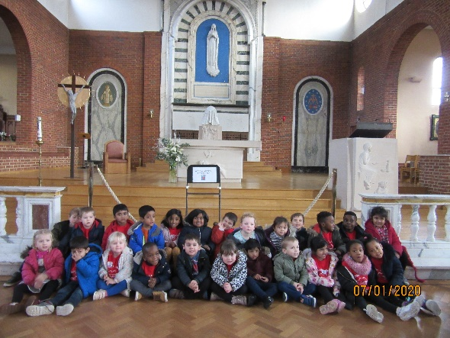

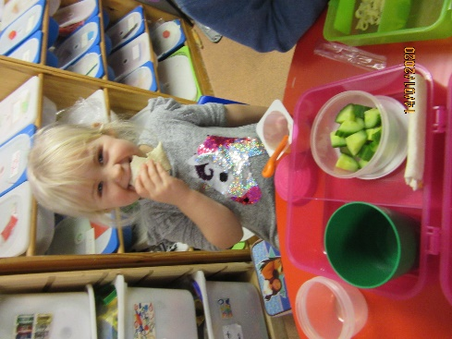

***Heating and any other issues***

Our recent issue with the heating has been resolved. We now have a new working boiler. We thank all parents for their patience during this matter.

Unfortunately, there will be occasions where the pre-school may have to be closed at short notice. We will endeavour to avoid closure at all times, but sometimes this may be out of our control. If there are multiple staff illnesses, we have a procedure in place which helps to avoid closure. However, we would not compromise on the safety of the children simply to stay open. Please note this procedure is displayed on the noticeboard in the foyer.

***Library***

Noah’s Ark’s library returns on Wednesday 15th January. If you still have a book at home, please hand this back in return for a new one. We encourage parents to read every day to their child.

***Key Person***

Your child’s key person is available to talk about your child on the day that she works. You can talk to any other key person if she is not present. It is our policy to support all children not just our key children.

***Illness and absences***

As a reminder and for all new parents please note that we cannot accept children who are ill. Especially, when experiencing fever, diarrhoea and/or vomiting, it is Noah’s Ark’s policy not to accept children for at least 48 hours after the last bout of symptoms. We very much appreciate your understanding in adhering to this policy.

Noah’s Ark also has a **no nuts policy**. Any donations of sweets and cake for birthdays should be free of nuts as well as treats in children’s lunchboxes.

Fruit for children should be cut to avoid choking. This especially applies to grapes, strawberries, apples and peppers.

***Dates for your diary***

**Superheroes and Princesses dress up day –** 29th January 20

**Half term holiday** – 17.2.20 – 21.2.20

**Parents Consultation meetings** – 3rdnd and 4th March 2020

Signing up sheets will be hung up the week before.

Thank you for reading our news.

Bettina Campion

Pre-school Manager