

**Noah’s Ark Newsletter May 2018**

Dear Parents,

A very big thank you to all parents who made the outing to Court Farm Garden Centre possible. What a lovely experience it was for the children who bought some nice plants and vegetables for the pre-school’s garden. All the children, including the younger ones, coped so well with the long walk and we were very proud of their immaculate behaviour whilst in the garden centre. The children have enjoyed planting the bought vegetables and flowers in the pre-school’s garden and we hope to reap the rewards of fresh vegetables very soon!

Our next outing will be to the library in Tolworth on Friday 18th May in the afternoon. Giselle Mondiot, librarian, will read a story and the children will be allowed to borrow books for the pre-school. If you can help, please tell any member of staff. The morning children will visit after half term. We have many more exciting activities planned in the coming weeks and hope to invite the police and the fire brigade to our premises.

Here is a selection of recent activities: walk to Tolworth Broadway (looking at signs), at the garden centre/planting and handling the chicks. Other pictures will be added to the website shortly.

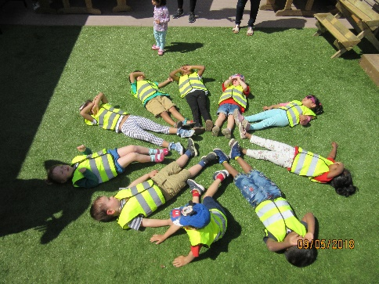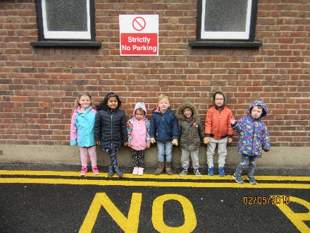

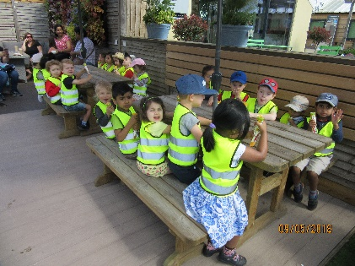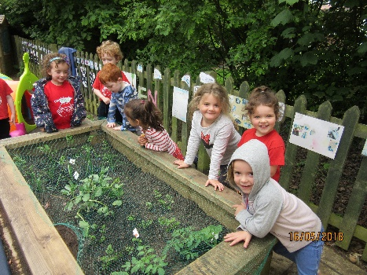

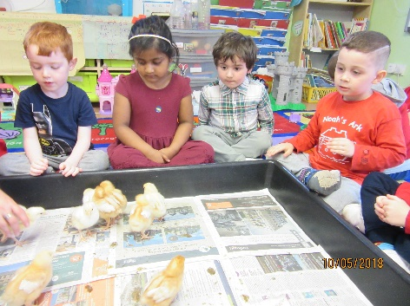

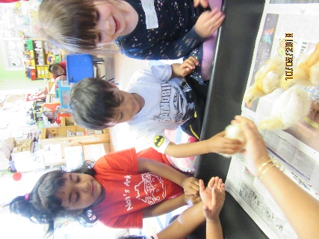

***Evacuation Policy***

We would like to reassure parents that in an emergency the children’s safety is our utmost concern. We regularly practise emergency evacuation procedures giving children plenty of opportunities of what is expected of them should a real emergency arise. We will update our policy to read ‘in the event of an emergency that requires the immediate evacuation of the pre-school, a named person will inform the school as well as the presbytery in order to ensure safety for all situated on the Parish grounds.

We have recently reviewed our door policy and would like to propose to buy a new set of front doors as well as lockable doors to the main room. This will make the pre-school even safer for children and staff. If you know of a business who would be able to give a reasonable quote for new outside and internal doors, please talk to either Bettina or Jo Oakley, our chair person.

***Chicks!***

What a lovely experience the children had with the hatching of chicks. We had 9 chicks hatching in total. The children learned to look after them and how to handle them with care. It is wonderful to know that we are able to offer the children this worthwhile activity every year. This year we had two families, Aaron and Grayson’s, offering the chicks a good home. ☺

***Donations***

The pre-school was in need of some repairs in the playground and we would like to say a heartfelt thanks to Kacper’s dad, who repaired various woodwork for free. He also donated some offcut artificial grass. The children now benefit from a safe and comfortable groundcover. ☺☺

We have also had an anonymous donation of stationary given to us for which we are very grateful. ☺☺

***30 hours spaces in September 2018***

If you are applying for 30 hours in September, please be mindful to do this nearer the time such as June/July/August, but no later than that. There is a cut-off date where funding will not be granted if the application through HMRC’s website has been received too late. If you need help with deciding on the extra 15 hours please talk to Bettina or Theresa.

***Dates***

**Library visit – 18th Mary,** 1.30pm,afternoon session only. Parents will be asked to support this event.

**Library visit – 8th June**, 9.30am, morning session only. Parents will be asked to support this event.

**Sports day - Friday 25th May,** 11am and 2.30pm for parents to join their children**.** .

**Last day of half term:** Friday 25th May – Noah’s Ark returns 4th June

**Noah’s Ark Family BBQ – 30th** **June** – Please save this date in your diary. Details to follow nearer the time

**Last day of summer term**: 13th July 2018

Bettina Campion

Pre-school Manager