

**Noah’s Ark Newsletter November 2017**

Dear Parents,

Thank you for attending our parent consultation meetings in such great numbers. We appreciate your support and hope that we can work together on your child’s individual next steps. If you still have a Learning Journey at home, please return them urgently.

A big thank you also to all the parents who accompanied us on our walk to the park. The children have used many of the leaves, sticks and conkers in our activities and these are displayed around the pre-school.

Our trip to the Rosclaire Old People’s home was also successful. Eight children in the morning session visited the home and sang nursery rhymes with the resident, they were delighted to see our children. Some residents will visit us for our Christmas play dress rehearsals. For our next visit, different children will be selected to attend. Unfortunately, the home is only able to accommodate 8 children at a time.

The children also enjoyed a visit of Niamh Powell’s pet hedgehog which fitted perfectly into our Autum themes topic. A big thanks to both Mum and Niamh for bringing him in.

Please see a selection of photos of both activities below. The photos will be added onto the website in due course.

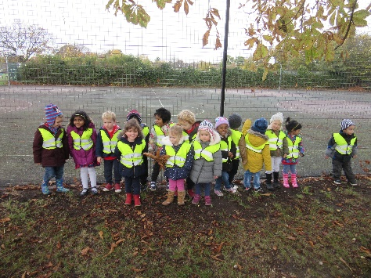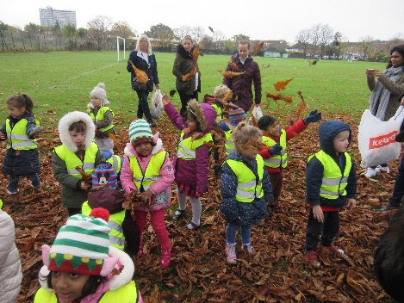

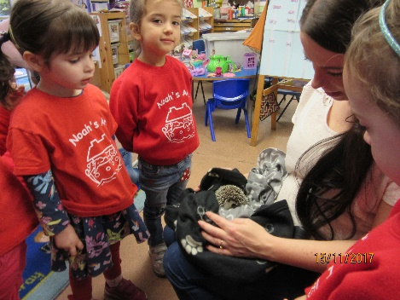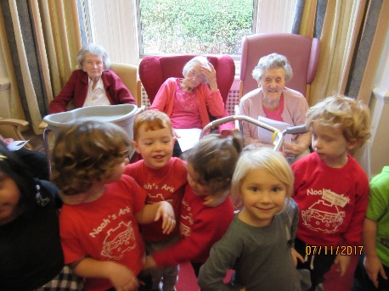

***Safeguarding***

We take safeguarding seriously at Noah’s Ark and have set procedures in place to protect children from harm at our premises and on outings. Our policy and procedure is hanging up on the notice board, but can also be accessed online on our website. I have attached an abridged version to this newsletter for your information.

***Committee Members***

Our new and existing committee members’ names and roles are attached to this newsletter. We look forward to a long and fruitful relationship with all of them.

***Learning Opportunities***

This term we are concentrating on maths activities. To support this at home, encourage your child(ren) to count actions such as clapping hands, jumping, marching. For example ‘how many steps can you count from the door to the gate?’ Number recognition can be supported by talking about important dates such as birthdays or numbers on houses as well as buses. If you have kitchen scales, let your child measure out ingredients and read the number on the dial/display. And finally, look at shapes in the environment ‘what looks like a circle, triangle, square etc.?’

***School fees***

When paying school fees, please would parents reference their child’s name on the bank transfer or when paying by cash. Many thanks.

***Dates***

**Cake sale –** 8th December 2017. Please support this event – details nearer the time

**Christmas play -** 15th December **11am** morning children and **2.30pm** afternoon children. We will advise on details such as costumes in due course

**Children’s Parties** – 18th December 2017

**Last day of term –** 18th December 2017

**Spring term reopening** – 3rd January 2018

Thank you for reading our news.

Bettina Campion

Pre-school Manager