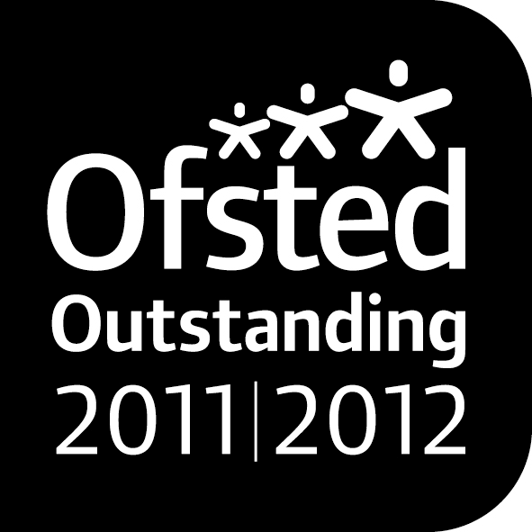

**Noahs’ Ark Newsletter November 2018**

*Dear Parents*,

This half term we have many activities planned. As always the autumn term towards the Christmas period will be very busy especially with practising the Christmas play for the morning children. Our topics this term include, *light and dark; autumn themes including books, healthy learning in early years, celebrations and autumn changes.* To support healthy learning in early years we have signed up to an accredited scheme as explained below.

We welcome, Michaela Rodrigues, a student from Nonsuch High School and former pupil of Noah’s Ark Pre-school. Michaela will work with us every other Wednesday afternoon as part of their community enrichment programme.

We thank all parents and carers who came on our walk last Wednesday.☺ It was a beautiful day and the children brought back lots of leaves and sticks for our activities. The photos of this walk have been posted on the website as well as the ones from the coffee mornings.

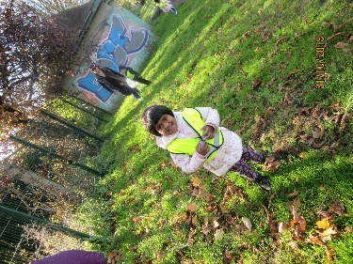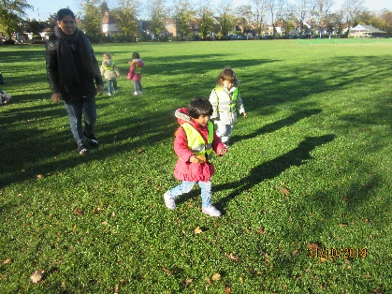

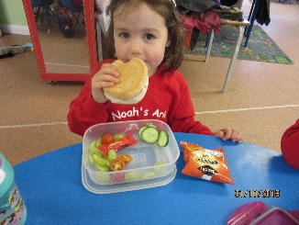Last week’s lunch time award for healthiest lunch box goes to Amelia Goldsbrough. Her lunch included lots of fruits and vegetables. Some of which we are offering at snack time as well. Well done!

***HEYL Scheme***

Noah’s Ark has signed up with this scheme which was introduced by our London Mayor. It promotes healthy eating and lifestyles. We will be working towards awards and hope that all our parents will be on board to promote this worthwhile scheme. Further details to follow shortly.

***Our new Committee***

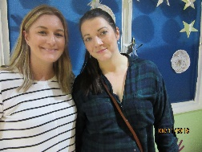Following our AGM in October our new committee for this academic year has been elected. The members and their roles are as follows:

Jo Oakley – Chairperson (Alicia’s mum) on the right

Candice Lynn – Treasurer (Francis’ mum) on the left

Tara Kenny – Secretary (Archie’s mum)

Elisa Goldsbrough – Committee member (Amelia’s mum)

Chaminda Karunaratne – Committee member (Yenuli’s dad)

Lucinda Walsh – Committee member (Harriet’s mum)

We look forward to working with you!

***A special thanks***

Emanuele and Helen Orlando donated two refurbished computers and repaired our broken one. Emanuele installed these during the half term holidays at Noah’s Ark. We are most grateful for their generosity and giving up their time to set the computers up for us! ☺☺

***MacMillan coffee morning and afternoon***

Our coffee mornings were very successful. Parents joined their children who sold cakes to fundraise money for our chosen charity Macmillan. Despite many children being off on that day we still raised a super **£117.58**. The money has been paid to Macmillan.

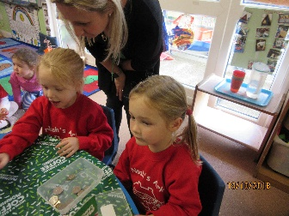

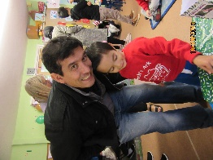

***A new Smartboard***

Our smartboard of 7 years stopped working properly. As this smartboard range is not manufactured anymore, we decided to invest in a brand new version. The money used will be from past fundraising. We feel that this is money well spent as we are using the smartboard on a daily basis for the children’s learning. The installation will take place on Wednesday 7th November. We will take all precautions necessary so that the daily routines of the children won’t be disturbed whilst the work is being carried out.

***Dates***

**Parents Consultation meetings** – 6th November 3.30pm – 4.30pm

**Parents Consultation meetings** – 7th November 3.30pm – 4.30pm.

**Pyjama Day** – 14th November

**Cake sale** – 7th December

**Christmas Play** – 17th and 18th December for morning children only

**Christmas Parties** – 19th December am and pm session

**Last day of term - 19th December**

Thank you for reading our news.

Bettina Campion

Pre-school Manager