

**Noah’s Ark Newsletter October 2017**

Dear Parents,

A big thank you to all parents who attended our parents welcome meeting in September. It was lovely to see so many of you. We hope that you found it informative and enjoyed the short video of your children. If you are interested in obtaining a copy of the film, please bring in a memory stick and I will copy it over for you.

We also held our important Annual General Meeting (AGM) yesterday. The meeting focussed on our financial situation of the past academic year as well as a report on the pre-school’s situation during that year. We said goodbye to Latoya, Shyamala, Steph and Suzanne who were longstanding members and they will be missed. We warmly welcome the following new members who were recruited at yesterday’s meeting: Elisa (Amelia’s mum), Melissa (Henry’s mum), Chaminda (Yenuli’s dad) and Kelly (Grayson’s mum). Jo (Alicia’s mum) has been re-elected as our chairperson and Candice, whose son is joining us in January, as our treasurer. A full list of our committee members and their individual roles will be issued shortly.

Please see below pictures of what the children have been up to:

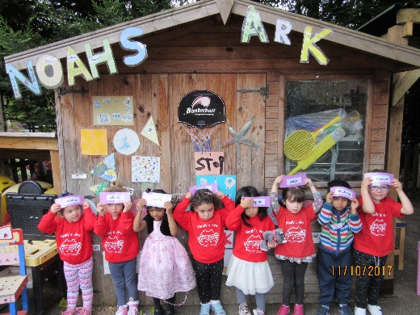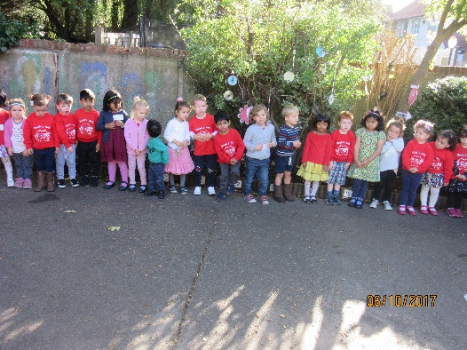

Lining up for our fire drill/emergency evacuation The first initial of our name spells Noah’s Ark

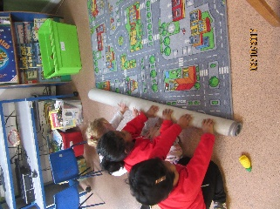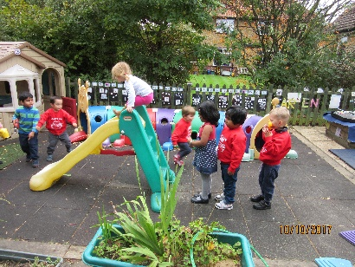

Tidying away Taking turns

***Last day of term***

We have changed our last day of term and are now open until 18th December. Consequently, children who attend on Mondays and are fee payers will have their 2nd half termly invoice amended.

***Donations***

We appreciate all the donations received so far. If you haven’t yet paid please be reminded that these donations pay for your child’s wide selection of snacks as well as the book bag and many other activities and resources.

***Fundraising***

Our next fundraising event is children’s handprints Christmas cards. Friends of Noah’s Ark and Committee members will help with handprints on Thursday 19th October during the sessions. Please support this fundraising event. Many thanks.

***Spring term register***

If your child is turning 3 this term, please let us know if you want to increase your hours at Noah’s Ark. We will be taking some new children in from January 2018 so it is important to let us know which days you prefer. Thank you.

***Dates***

**Coffee morning and afternoon** – **20th October 11am** for morning session and **2.30pm for afternoon session.** Parents are joining the children for a cup of coffee or tea and an iced cake. Monies raised will be donated to Macmillans charity.

**Half term holiday** – 23rd October. Noah’s Ark returns 30th October.

**Parents Consultation meetings** – 31st October 3.30pm – 4.30pm

**Parents Consultation meetings** – 1st November 3.30pm – 4.30pm. Signing up sheets are available in the foyer.

**Visit to Rosclare residential home** – 6th November 10.15pm

**Walk to the park** – 9th November morning and afternoon

**Christmas play -** 15th December **11am** morning children and **2.30pm** afternoon children.

**Children’s Parties** – 18th December

**Last day of term –** 18th December

Thank you for reading our news.

Bettina Campion

Pre-school Manager