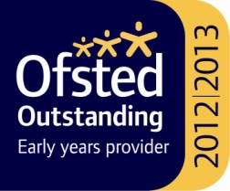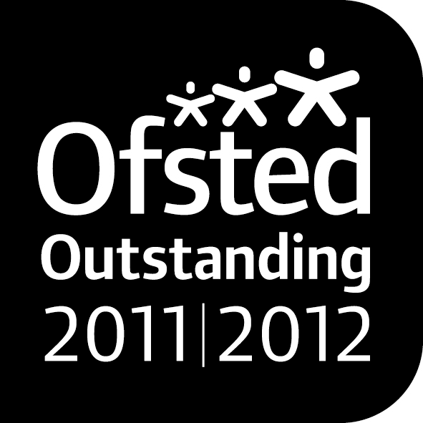

***Noah’s Ark Newsletter 28th April 2014***

Dear Parents,

We hope you enjoyed a restful Easter holiday. Many thanks for the chocolates and Easter cards we received.

The summer term will bring many exciting events for the children. Last week the long awaited two playhouses finally arrived. The children are absolutely delighted with these new additions. Thanks to the hard work of Klara’s parents, Artur and Anetta, the houses were assembled last Wednesday. They also took away the old children’s house leaving the playground safe for the children. We are very grateful to them giving up their spare time to help us with our two projects.

We have since rearranged the playground and intend to make the empty space around the old playhouse more colourful with plants so that the children can learn to look after plants all year round. This will also complement our present topic.

This term’s topic features around ‘The natural world’. The topic is divided into themes such as spring, flowers, planting and growth. To support the theme growth, the children will benefit once more from the ‘Living Eggs’ programme where they will experience the hatching of chicks starting on the 12th May 2014.

Elizabeth’s mum Victoria has also arranged for the fire fighters to visit us in the following weeks.

***Events***

**Cake sale** – 2nd May 2014 – please support this event with your home baked or shop bought cakes. Proceeds will go towards the ‘Living Eggs’ programme.

**Noah’s Ark Family BBQ** – 5th July 2014 – details will be available in due course, please add this fun event to your diary.

***Website***

.

The website will be updated this week with photos from recent events. Please visit the website to view the photos from the gallery.

***Lenten Project***

All proceeds from the last cake sale and coffee morning/afternoon have now been donated to the Lenten project and should appear in the next church newsletter. Thank you for your continued generosity to support the pre-school and our community.

***Student placements***

We now have 5 student placements (Maria, Saro, Marie, Letizia and Samar) who work towards levels 1-3 in child care once or twice a week. They support the staff in our daily routines in order to pass their required tasks and are supervised throughout their stay.

***Learning Journey and Reports***

Remember to return your child’s Learning Journey so that we can update it in due course. We will hand out your child’s summary of achievement at the end of June. If you would like to discuss your child’s progress before the summer term ends, please arrange a mutually convenient date and time with your key person.

Many thanks for reading our news.

Bettina Campion and Staff