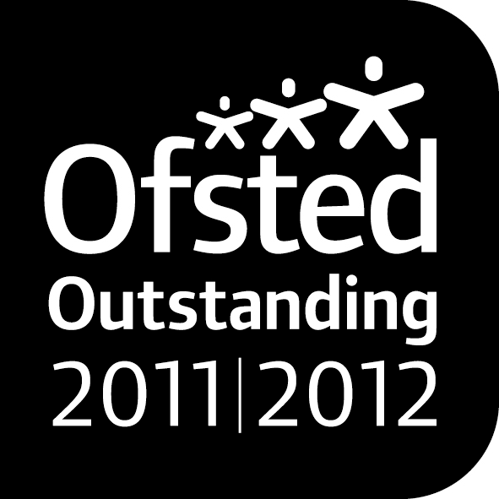

***Noah’s Ark Newsletter Update June 2014***

Dear Parents,

Unfortunately, the fire brigade cancelled their visit yesterday morning at short notice, but managed to arrive for the afternoon session instead. The children in the morning won’t miss out as they promised to rearrange it within the next two weeks. The children delighted at the real experience of using the hose and soaking the car park. We all enjoyed seeing Sandie dress up as a fire fighter!

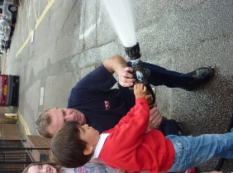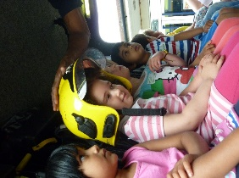

We still have more exciting events planned for the coming weeks, so please make a note in your diary.

***Sports Day –*** 20th June, morning parents join at 11.00am and afternoon parents join at 2.35pm. The children will be attempting an obstacle course. We appreciate a small donation on the day to buy sports equipment.

***Kingston Museum visit at Noah’s Ark –*** 27th June. Staff from Kingston museum will be talking about historical events and support this with storytelling, a work shop and a dance performance. This will take place during the normal session.

**Transition day –** Wednesday, 2nd July – Pre-school closed for the morning session. As most children will be visiting their new school, the staff will be preparing documentation.

***Noah’s Ark BBQ – Saturday*** 5th July from 1-4pm. This is Noah’s Ark’s biggest event of the year organised by the Committee and Friends of Noah’s Ark where staff, family and friends are invited to take part. Fantastic prizes are to be won and there will food and drink. Tickets are on sale now. Please support this fundraising event.

***Noah’s Ark Fun day and last day of term –*** Friday 18th July. We will be celebrating the last day of term on this day. Unlike previous years, there will be two separate events for the morning and afternoon children. Details will be published very soon.

***The Noah’s Ark website’s gallery*** is working again and has been updated with some of our events over the last year. We will continue to add more events. Please have a look to see the children in action.

***Our special thanks*** go to Stephanie, Naomi’s Mum, who kindly supplied us with another Microsoft Word version for our laptop next to the Smart Board. This will increase the learning opportunities for our children. Also thanks to Aaron’s family who donated a computer to Noah’s Ark which is presently used in the office. We very much appreciate your kind donations.

***The library*** will continue until 25th June. Please return all books on that day. Klara’s and Holly’s Mum in the afternoon have worked tirelessly in the library. Thank you so much for giving up your spare time for the children.

Many thanks for reading our news.

Bettina Campion and Staff