

**Noahs’ Ark Newsletter September 2019**

Dear Parents,

A very warm welcome to all our new parents and to those who returned from the last academic year. We hope you all enjoyed a relaxing holiday with your families.

We look forward to helping your child learn and have fun at Noah’s Ark during the coming year. There are, no doubt, a few things that parents are unsure about and we therefore, invite our new and ‘old’ parents to our Welcome meeting on the 24th September at 7pm. All team members will attend as well as members of our pre-school committee. There will be an introduction by myself to the routines at Noah’s Ark and how children are taught to become confident learners. There will also be a short video of most children attending the pre-school. Please join us on this evening.

For this term, our topics are *‘Fabulous me’* including *my home and family*, my favourite *toys/books, rules and routines at Noah’s Ark, Healthy eating and hygiene and nursery rhymes.* The team will provide stimulating and exciting activities to support your child’s starting points and development.

We hope that you and your children will enjoy a pleasant and exciting year at Noah’s Ark.

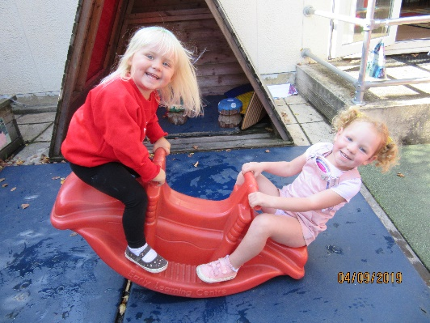

**Fun with friends**

***At the start and end of session***

Please arrive promptly for drop off and collection. The earlier parents arrive, the earlier we can do registration. We prefer for parents to stay in the foyer as once children start playing there should be no adults in the main room. Our morning session finishes at 11.40am. Please try your utmost to collect on time as all day children need to be prepared for lunch. If you are late please ring and let us know so your child can be told and does not become anxious**.**

***Learning Journeys***

If you are a returning parent please bring in your child’s Learning Journey so that we can begin updating it with their work and photos. All new children will receive their Learning Journey at pre-school. We will send out the Learning Journeys three times a year for parents to add something from home. Learning Journeys can be accessed at pre-school by parents.

***Library***

Noah’s Ark offer a library on Wednesdays and it will return next week 18th September. Children are encouraged to select a favourite book to take home. They can keep the book for one week and return it the following Wednesday. We encourage parents to read every day to their child.

***Team News***

**Nevila** has recently gained her level 3 qualification in childcare and education. Many congratulations from us.

**Latoya** will be starting her level 2 course next week and we wish her all the best in achieving this qualification

We were inspected last Friday by Kingston Council for hygiene in the kitchen and infection control. We again received the highest level 5. Well done to the team for keeping everything clean and hygienic!

Your key person is happy to talk to you about your child on the day she works. However, our policy is to know all children well and you are able to discuss matters with other team members. If you have any concerns, please talk to me or Theresa. We are here to help.

***Illness and absences***

Please note that we cannot accept children who are ill. Especially, when experiencing fever, diarrhoea and/or vomiting, it is Noah’s Ark’s policy not to accept children for at least 48 hours after the last bout of symptoms. We very much appreciate your understanding in adhering to this policy.

Noah’s Ark also has a **no nuts policy**. Any donations of sweets and cake for birthdays should be free of nuts, but also the children’s lunch boxes.

Fruit in lunch boxes should be cut to avoid choking.

**Children’s clothes**

Many children are wearing Noah’s Ark jumpers and t-shirts, please try and label all your children’s clothing with their names. Otherwise, their clothes might go home with the wrong child.

***Dates for your diary***

**Parents welcome evening** - **Tuesday 24th September 7pm** – a separate invitation will be sent by next week.

**Annual General Meeting** – November - more details will follow.

Coffee morning and afternoon – 25th October **11am** for morning session and **2.30pm for afternoon session.** Parents are joining the children for a cup of coffee/tea and fundraise for **Macmillan Cancer Charity**

**Half term holiday** – 28th October until 01st November. Noah’s Ark returns 04th November.

**Parents Consultation meetings** –12th and 13th November 3.30pm – 4.30pm

Signing up sheets will be hung up the week before.

**Christmas Parties** – 16th December - am and pm

**Christmas Play** – 17th December - morning children only

**Last day of term – 17th December**

Thank you for reading our news.

Bettina Campion

Pre-school Manager