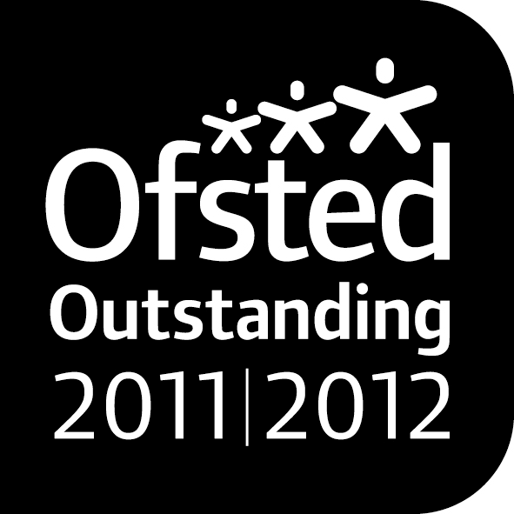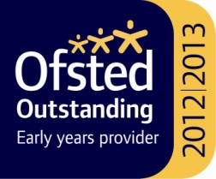

***Noah’s Ark Newsletter March 2016***

Dear Parents,

Our recent parents consultation meeting was well attended and the staff team thank you for your time to discuss your child’s learning and development. Please return your child’s yellow learning journey as soon as possible so that we can begin updating for the next cycle.

This term’s topics include *stories, senses, Easter and road safety*. To support road safety this week, the children will be taken in small groups to cross the road outside the church.

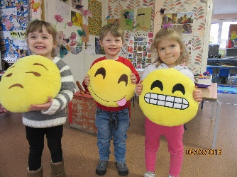We have noticed that some children find it hard to express their emotions appropriately and often hit out not only at their peers, but also the teachers. As this is upsetting and also unacceptable behaviour, we are supporting their emotional development with our senses topic. We recently acquired happy, sad and angry cushions to support this stage in their learning. If you need any support with behaviour at home, please talk to us and we will collaboratively work on strategies.

**Parking**

At the request of one parent, whose child was nearly run over, all parents are asked to take particular care when driving on site.

As you know, parking is not permitted during certain times. Recently, the church car park was blocked completely. In an emergency no ambulance or fire engine would have managed to get through. Please take extra care.

**Dates**

**Cake sale –** 11th March – please bring in your lovely home baked cupcakes – all proceeds will be donated towards the Parish Lenten Project.

**Coffee morning and afternoon –** 18th March – please join your children at 11pm in the morning and 2.30 in the afternoon.

**Easter holidays –** last day 24th March – Noah’s Ark reopens Monday 11th April

**A short story – Friend or Foe**

Maria Medeiros (Valentina’s mum) has written a short story which was accepted on the digital magazine website Kisboo. Have a read by following this link and please vote for it. [http://www.kishboo.co.uk/issue_6b/story_15.p](http://www.kishboo.co.uk/issue_6b/story_15.php)

**During illness**

In recent weeks we have had a number of illnesses ranging from sickness and diarrhoea to chickenpox and fever. Please do keep your children at home and observe the 48 hours rule as per our policy and that of Ofsted. In the meantime, we have suspended some activities such as water or sand to avoid spreading germs.

The children are regularly reminded to wash their hands and we talk about hygiene in general. Please do support this at home and remind them of washing their hands after toilet and before eating.

We are often asked not to let children out when they return, but fresh air will aid recovery and if they are too ill to go outside they are also too ill to be at Noah’s Ark.

**Fundraising news**

Our pyjama day raised a fantastic £ 35.80 Many thanks for supporting this event ☺

**Survey**

A big thank you to all 32 parents who returned our questionnaire. Questionnaires help us shape the future of Noah’s Ark and improve our provision. Only one parent felt that their child was not yet settled and this has been addressed since. Overwhelmingly, all parents felt that the staff team provide enough information about activities, events and learning development.

There have been some very positive comments about our key person system. A parent suggested that learning journeys should be placed in the foyer so that they can be read. Unfortunately, we do not have the space for this, but we would encourage parents to enter the main room and look at the learning journey with their children.

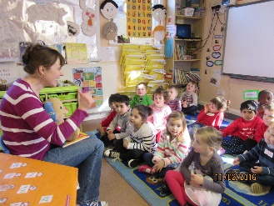Some parents offered to come to Noah’s Ark and help with an activity or talk to the children about their job. Please see below photo of Benedict’s mum who gave a fun lesson in German.

Many thanks for reading our news.

Bettina Campion