

***Noah’s Ark Newsletter Update 15th April 2015***

Dear Parents,

We hope you had a relaxing holiday with your family. We very much appreciated your cards and Easter chocolates. Especially, the chocolates will keep us going at lunch time! Many thanks from all of us.

Our term starts with the following topics: **Spring including plants and growth, Senses and Feelings and St. Geoge’s Day.**

We will be planting flowers in the garden and growing seeds in pots. Today, we will be visiting the flower shop in small groups and buy plants for the pre-school.

At present, we have some live caterpillars for children to learn about their transformation into butterflies over the next week or so. The children will be encouraged to note the changes of the caterpillar every day.

Below are some pictures from the flower shop trip and the caterpillars.

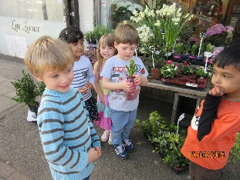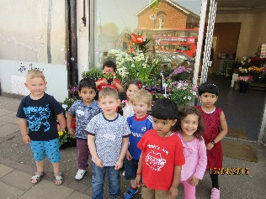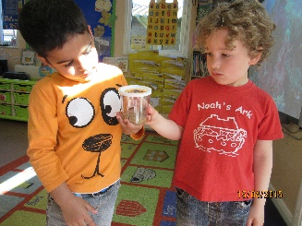

***School places***

All parents will be informed of their child’s place at Primary school on Thursday 16th April. Please let us know which school your child will be joining so that we can arrange contact in due course.

***Learning Journey***

Please return your child’s Learning Journey so that we will be able to update it with your child’s work and pictures. The Learning Journeys will be handed out after the next half term holiday and you will be able to keep them. Those children who stay on for another year will need to return their Learning Journey again.

***Website***

The website will be updated shortly with photos from our coffee morning and afternoon, dates and topics.

***Warm weather***

Please make sure that children are dressed appropriately in warm weather. Hats will be needed if it is sunny and sun cream should be applied before the session. We would strongly advise against open toe sandals or flip flops as children are more likely to hurt themselves.

***Dates***

**Cake sale 1st May 2015**

**Sports day 19th June at** 11.00am and 2.30pm

**Noah’s Ark Family BBQ and 15 year Anniversary Celebration** 27th June 2015; more details to follow in due course.

**Last day of half term** 22nd May 2015 we reopen on Monday 1st June.

**Last day of summer term** 15th July 2015

***Message Board***

With the warmer spring weather appearing, many of you will be out and about with your children. Why not tell us about your activities on our parents’ message board. We would like to hear about what your children have been doing. This will encourage your child to talk about past events at register or circle times and support learning in communication and language. All messages will be put in your child’s Learning Journey.

Many thanks for reading our news.

Bettina Campion

Pre-school Manager