

**Children’s News April 2020**

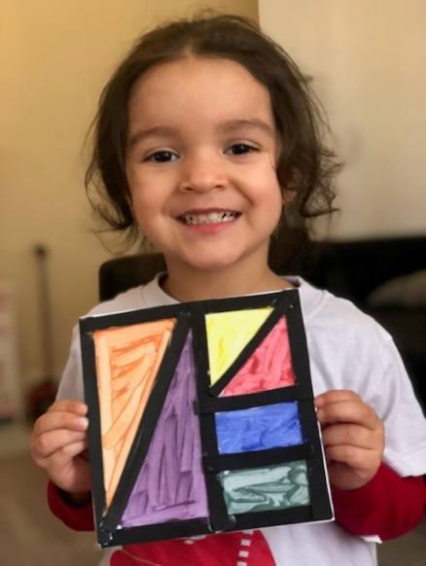

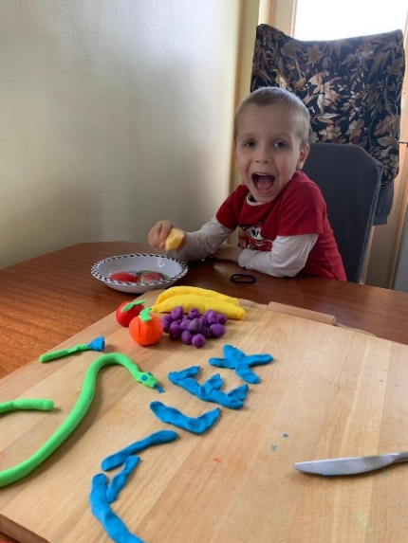

Alex’s name with

playdough

Estefani’s drawing

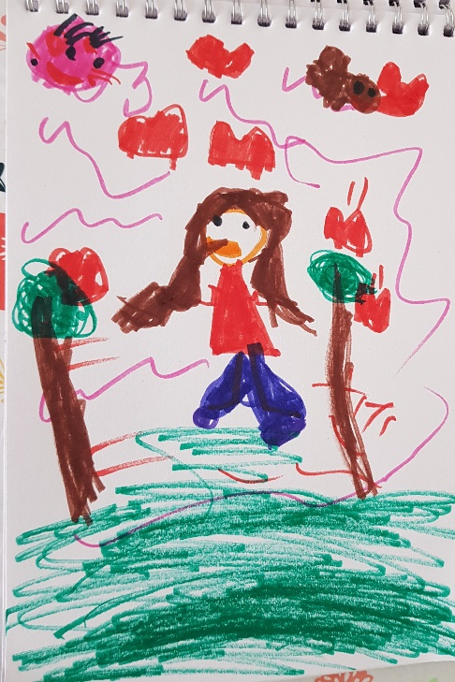

Rosu’s drawing

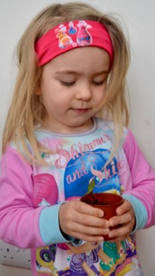

Erin’s plant



Dear Parents,

Since my last update not much has happened, especially, as we are no closer to a date as to when we can reopen. I am hopeful for June. The website is now updated and running.

At present, the team has a rota to visit the pre-school regularly, this is to check for any post, phone messages and running the taps as well as flushing the toilets which was advised by Public Health at the start of the lockdown. Some team members are attending online courses and/or reading up on the latest developments in Early Years. We also have our planning ready for when it is time to reopen.

Please continue to send in pictures of your child doing an activity or a picture of your child’s drawing. I will continue to collate them for the website and newsletters, but more importantly they will be used for a **booklet** as a memory for their time at home in lockdown. It would be lovely if more parents would send in photos to Noah’s Ark.

We would like to suggest the following activities, but they are just suggestions if you feel they may benefit from them:

**Favourite books**: ‘A Squash and a Squeeze’, Julia Donaldson; ‘Giraffes can’t dance’, Giles Andreae and ‘Little Red Hen’, various authors.

**Activities:** During any physical activity such as going up and down the stairs ask them to count them thereby realising that anything can be counted and not just objects. Please take a picture.

**Garden:** Supply a blanket to build a den or pretend camping. This is also good for inside. Going on a bug hunt. Supply a tub or similar with a few leaves and let them find ladybirds etc. Stories by Eric Carle ‘The Very Hungry Caterpillar’, The Very Quiet Cricket’ etc will fit in with these themes. Please take a picture and send to Noah’s Ark.

**Physical activities:** ‘Move and Freeze’ on YouTube by the Learning Station.

That’s all for now!

I will continue to keep you up to date with any news.

Stay well,

Bettina