

**Children’s News May 2020**

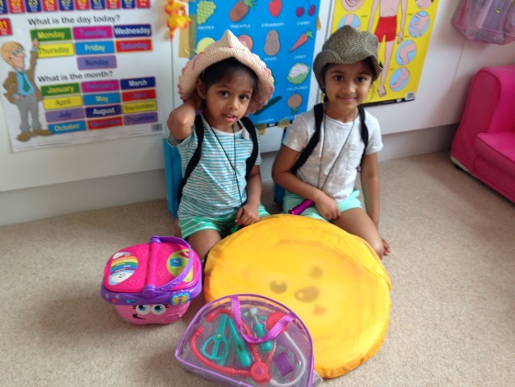

Chanuli camping at home

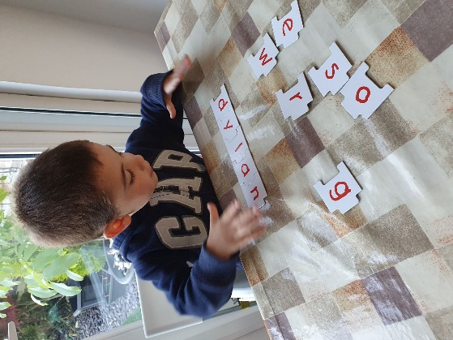

Dylan writing his name with alphabet puzzles

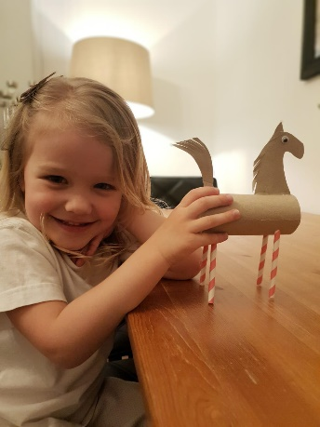

Greta’s loo roll challenge

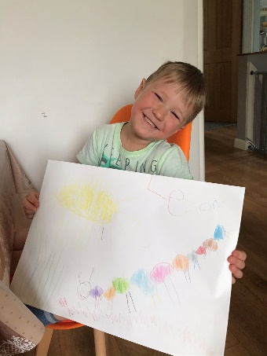 Leon and his caterpillar drawing

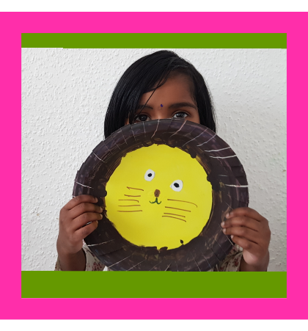

Roseann’s lion mask

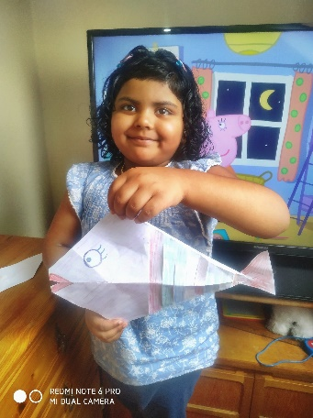

Sandhwana’s fish



Dear Parents,

I hope everyone is still well and staying safe.

We are finally seeing some changes with recent lockdown restrictions lifted. The Government is beginning to reopen schools and this means we will be back once more on the 1st June, albeit, with a very reduced number of children. Please let me assure you that all team members are very happy to have some normality back and we are ready to take on the challenge.

I have attached our reopening procedure which will be our guiding policy throughout the next few weeks. Please read this very important document. We will amend as new guidance is issued.

For those of you who have opted to return their child to Noah’s Ark, I would like to advise on a few matters that need your consideration:

**Emotional wellbeing**: Please talk to your children that things will be different and that they need to wash their hands more and that some activities may not be available because of the virus e.g. playdough. Please also mention that some of their friends may not be back. Your child may not want to leave you at the door, so they may need more encouragement than usual as we won’t be able to take them off you.

**Queuing:** When queuing up to enter, please wait at the bottom of the ramp. A team member will call your child up or you come to the door. We will have a line marked at the bottom and then one more line for the person after you 2m away. As there are only 10 children in the morning, we don’t expect a long queue. We will do the same at collection time. A team member will send your child to you. Please wait at the bottom.

**Toys**: Do not allow toys to be brought in and do not bring your child’s book bag. Their work will be given by hand.

**Hygiene:** Please make sure they come with hands washed, but we will supervise handwashing again when they enter. Children have to wear fresh clothes every day. Lunchboxes need to be cleaned every day. We will hand them out for them. Please fill them with things that can be easily opened. Oranges have to be peeled.

**Illness:** If your child is ill, do not send them to school. If you give your child Calpol they cannot attend Noah’s Ark until at least the next day. Any child that displays symptoms of Covid-19 at Noah’s Ark will be isolated until collected. We expect children to be collected promptly if they are ill.

**Photos**: Please continue to send photos so they can be either published on the website or in the newsletter. There will be some more published on website in due course.

Here are a few more activity and book suggestions to try out:

**Favourite books read at Noah’s Ark**: ‘Lima’s red hot chilli pepper’ by David Mills, ‘Jack and the beanstalk’, ‘The Gruffalo’ by Julia Donaldson; ‘Oliver’s vegetables by Alison Bartlett’, ‘I love you this much’ by Lynn Hodges. ‘We are going on a bear hunt’ by Michael Rosen.

**Youtube**: https:youtube.be/kBi_RoXKVo0. Ten Magic Butterflies. Read Aloud Picture Books.

**Garden Activities:** If you have a garden you could set up an obstacle course for your children as we are not having a sports day which would usually happen in June. Please take a picture. Plant seeds such as sunflowers or beans either in the garden or in a small tub. This activity ties in with ‘Jack and the bean stalk’. Make a salad with vegetables from the book Oliver’s vegetables this will help them learn about healthy eating.

**General activities:** If you read the ‘Hungry caterpillar’ with your children, see if they can remember everything that was eaten by the caterpillar, then count with them how many items they remember. After reading stories to them a few times, ask them to retell some or all of it. All of this will help them developing a good vocabulary.

We endeavour to make your children’s time in their last few weeks at Noah’s Ark as fun and safe as possible.

That’s all for now!

I will continue to keep you up to date with any news whether you are at Noah’s Ark or at home.

Stay well and safe,

Bettina