

**Children’s News June 2020**

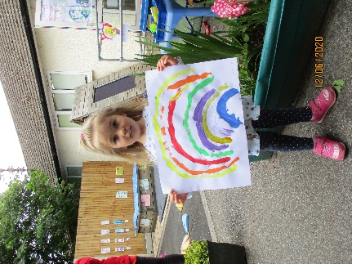

Erin’s NHS picture

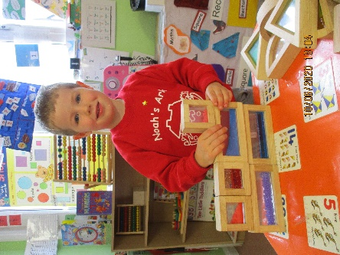

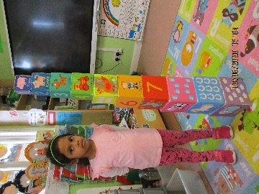 Harry exploring shapes

Alex’s painting

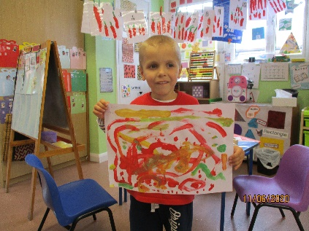

Chanuli’s tower

**And here are some more pictures from children from home**

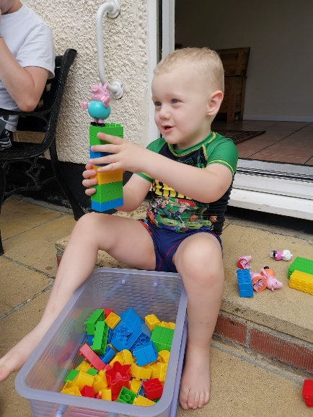

Finley building with Lego

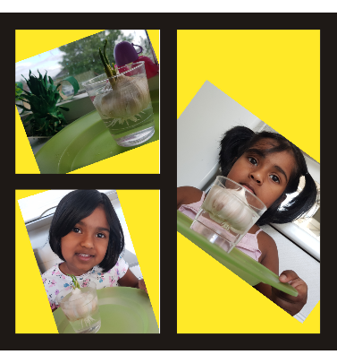

Roseann growing garlic

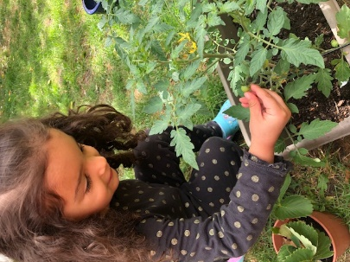

Estefani’s plant



Dear Parents,

I trust that you are all keeping well!

We are now in our 3rd week and fast approaching the summer holidays. After such a long time of forced closure it felt good to be back. Unfortunately, the virus situation has still not dramatically changed so we only have few children attending both morning and afternoon session.

All of the children who have returned appear to be doing well and I can assure parents that it is as bustling as ever. Much of the first weeks were spent learning about Covid-19, social distancing and increased hygiene measures. We work with 3 team members and strict hygiene routines are performed throughout the day. The children have adapted well and are taking the new situation in their stride. Yes, we do have less resources available and children do notice these things. However, as they are very resourceful, they have now resorted to making up games very quickly. We spent as much time as possible outside. Unfortunately, due to recent heavy and prolonged downfalls, it has made it near impossible to consider taking in more children as our rooms are not designed for easy social distancing.

If you wish for your child to return due to work reasons, we will need a week’s notice and I will look at it on a case by case basis. No firm promises can be made.

I would like to thank all parents who have already paid their contribution of £12.50. As you can imagine our income is drastically reduced with barely any fee paying parents and fundraising events this term to help with additional expenses. We received a generous and anonymous donation of £50 and are very grateful for this.☺☺ It will be put towards a new rug for register time.

There will be one more newsletter and I hope that we will have more positive news about social distancing and the virus in general.

Please note that our last day of term is 17th July finishing at 2pm.

Thank you for reading our news.

Bettina Campion

***Learning Journey and other documentation***

We will update the Learning Journeys of the children who are presently attending with a few more pictures and work during the next few weeks. If you still have your child’s LJ at home, please leave it there and we will send single pages for you to stick in. We will ensure that LJs are clean before sending them home at the end of the term.

We will not issue year end reports this year and the school will not require the usual Individual Development Maps (IDM’s) documentation. There are too few weeks to assess the children who are presently attending and our last reports were issued in March just before lockdown. We will, however, inform OLI of any noteworthy issues such as speech and if other professionals are involved in the child’s care.

***Topics/activities***

For this and next week our topic is ‘science’. We will try and incorporate as many activities as possible, but unfortunately, sand and water cannot be used. For parents who are at home you could make paper airplanes and boats with your children so they learn about flying and floating. Sinking and floating experiments in a water bowl with items such as stones, shells to sink and cork, rubber ducks, boats to float. You could also try a volcano experiment outside with them. Here is one link, but there are many more on youtube. <https://www.youtube.com/watch?v=8AqoOOJ3H_I>

Ruwani, Chanuli’s mum, suggested the following activity to make a picture with shaving foam.

Spray the shaving foam up to 1 inch.

Add your colours in the pattern you like on the shaving foam.

Use toothpicks or Skewers to mix it to make a design.

Get a foot ruler and level the shaving foam.

Place an A4  sheet on the levelled Shaving Foam and press gently.

Leave for 1 minute and lift the A4 sheet.

Then let it dry for few minutes to see the design.

As we are unable to perform a sports day in front of parents, we will arrange for a dedicated day for them to perform an obstacle course. This event will happen during sport activity week which is planned for week 5. We will take pictures for the learning journeys.