

***Noah’s Ark’s Newsletter***

Dear Parents,

A very warm welcome to our new parents and those who are returning to us. It is lovely to see you all after this long time, especially, as some of you have not been here since March. ☺☺

Thank you for your patience during this pandemic and all the extra measures that are in place at Noah’s Ark. The queues in the morning appear to be easing so we experience no problems taking the children in and support their handwashing. The children are beginning to settle and have readily accepted the handover at the door. Whilst this may not be ideal, children have quickly adapted to this new routine.

I am frequently being asked about our policies regarding illnesses/hygiene. Our new policies will be uploaded onto our website this week. In the meantime, please note that we can accept children with a slight cold or cough. However, we will not accept children with a fever and, routinely, we are taking their temperature with a fever scanner. A fever for children, according to the NHS website, starts at **38c** or higher. Please bear in mind that a child with a cold can feel quite unwell and tired so please keep them at home even if they do not have a fever.

As we are presently unable to hold a welcome meeting, please email or phone me with any questions you may have. Your welcome pack will give you general information about our routines including key persons photos and the website will soon have some pictures of this year’s children added.

From next week, we will be introducing more formal activities again and this term’s topics are ‘wonderful me’, ‘space’ and ‘jungle’.

Bettina Campion

**Lunchtime**

If your child stays for lunch please ensure that fruit, especially grapes and apples, is cut up in small pieces. We reward a special sticker to the child with the healthiest lunch box. The team are hoping to work towards a bronze award for healthy lunches, but this will depend on courses being delivered during the pandemic. Please see below picture of our lunch time.

**Family Photos**

To support our topic ‘wonderful me’, we are asking parents to send family photos in. Please supply at least two pictures that we can use for our traditional family poster. Any spares that we receive will be displayed around the foyer for children to see. The children love to see their own family on the poster and it can help children to settle in. At register time, we will ask your child to talk about their family photo.

**WhatsApp**

If you haven’t signed up for Noah’s Ark’s Parent WhatsApp, please let us know and we will forward your name and mobile number to Jo Oakley, our committee chair.

**Labelling of clothes and lunchboxes**

Please label your child’s clothes and lunchboxes with their names, especially their Noah’s Ark jumpers and t-shirts. There are quite a few coats, bags and lunchboxes that look similar, too. Bags with spare clothing should be left at Noah’s Ark. Many thanks for your support in this matter.

**Osted report**

Please find the latest report on our website or by clicking on the link below.

<https://files.ofsted.gov.uk/v1/file/50152341>

**Kingston Children’s Centre**

If you would like to attend services of Kingston Children’s Centre, please sign up for an online registration on the link below. This is for new registrations only.

<https://surveys.achievingforchildren.org.uk/s/4N2XVF/>

***Dropping off and Pick-up times***

As most of the children have settled into their routines now, please bring them at the normal session time which is at 8.40am & 11.40am in the morning and 12.15pm & 3.15pm in the afternoon. Please stick to these timings as early collection in the morning and afternoon does disrupt the session and children are missing out on our closing routines which includes a story. Thank you!

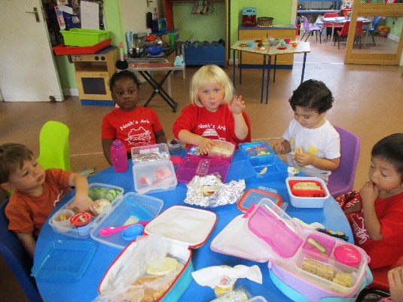

**Lunch time**

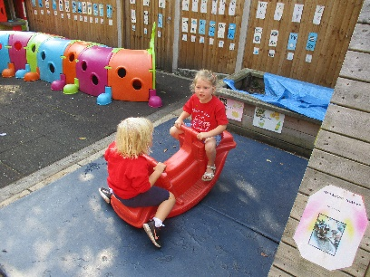

**Making friends**