

**Noah’s Ark Newsletter February 2021**

Dear Parents,

Winter has arrived and the children are enjoying activities around winter themes. It is also our last week before the half term holidays.

If it is very icy, we will avoid using the school playground and remember to send your children in with warm coats.

We say goodbye to Luis Toner Ferreira who leaves us this month for his new home in Lincolnshire. We wish him and his family all the very best and we will miss him dearly.

Please continue to pray for the family who have lost a loved one. Our thoughts and prayers are with them at this difficult time.

Stay well and safe

Bettina Campion

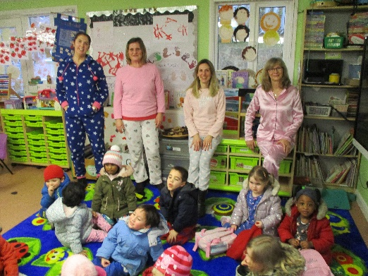**Our pyjama day!**

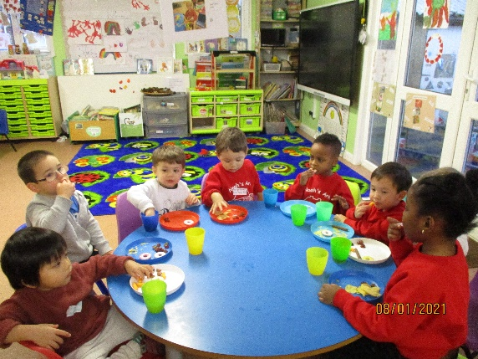 **Christmas party in January**

**Fundraising News**

Our Christmas Wreath competition has now totalled **£45**. Many thanks to Leonardo who brought in his wreath last week. We also had a big success with our pyjama day which raised **£57**.

The Christmas cards fundraiser achieved **£110** and the Christmas sweets raised **£214**. These are such big amounts and we thank our organisers Jo Oakley and Lucinda Walsh for taking on these events. Many thanks also to all parents who bought cards and sweets. We are very grateful for your support and have allocated this money for the ‘Living Eggs’ (chicks) experience and a new children’s tool workbench for outside.☺☺

**Presents from Noah’s Ark parents**

We would like to say a huge thank you to the very generous Christmas presents received yesterday from Tanith (Primrose’s mum) on behalf of Noah’s Ark parents. We feel very blessed that parents collected for us when we were closed due to Covid-19 before the Christmas holidays. It is very much appreciated. ☺☺

**Policy regarding Covid-19 symptoms**

If a child becomes ill with symptoms of Covid-19 at Noah’s Ark our procedures will be as follows: The child will be isolated by a team member who will be wearing PPE. The parent will be advised to take their child for a test. If you do not take your child for a test your child must self-isolate for 10 days. If the test is negative, the child can return provided that they are well. Please do inform us if your child develops Covid-19 symptoms at home so that we can take appropriate action for all at Noah’s Ark.

**Dates**

Dress up day in your favourite book character – **9th March** Please donate £1 or £2 if you can.

Half term – **15.2.21 – 19.2.21**

Parents Consultation evening by phone – **02.03.21** – timings will be given after half term.

Easter egg hunt on **31st March**

Easter holidays – **02.04.21 – 19.04.21**