

**Noah’s Ark Newsletter January 2021**

Dear Parents,

Welcome back and a very happy New Year to all of you. After a long break we are very happy to be back at Noah’s Ark. The team have recovered from their illness which took much longer than expected. We will continue with our stringent hygiene routines and would like to reassure parents that there will be little risk of transmission of the virus to the children. Those team members who have not had Covid are participating in regular fast flow testing at testing centres in the borough.

Our topics for this spring term are **Healthy me & hygiene** continued, **winter animals**, **my science**, **Themes around winter**, **colours** & **traditional stories**. We will continue to publish our daily activities on the whatsapp parent group with an occasional video as well. We hope that parents, who have decided to keep their children at home will benefit from these too.

We are saying goodbye to Estefani Ramos who has now arrived at Grand Caymen with her parents. Please see below picture of her friends saying goodbye to her.

Bettina Campion

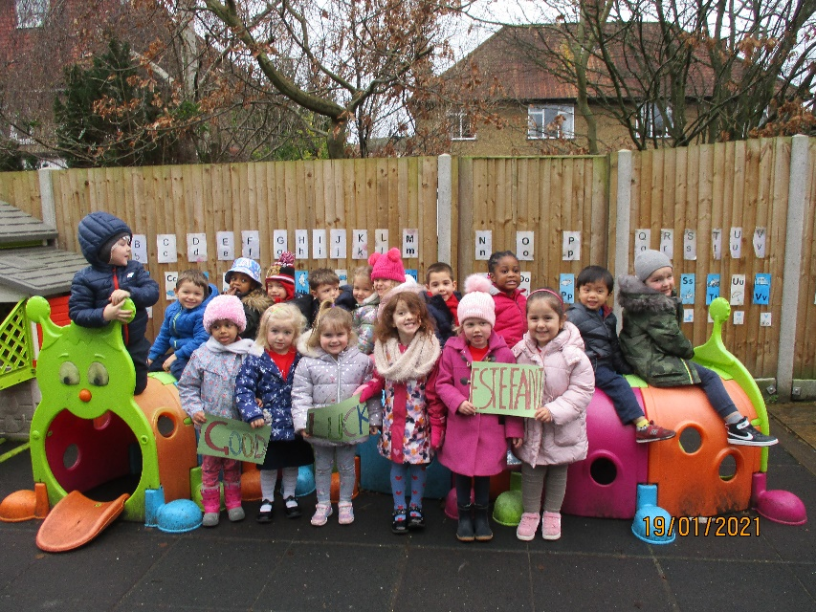

**Fundraising News**

A big thank you to Evie, Debbie, Chanuli and Greta who completed our Christmas Wreath competition and fundraised £40 in total. All four of them will receive a small reward ☺☺

Also, many thanks to all parents who took part in buying Christmas cards and mugs as well as Christmas sweets. These events were organised on behalf of the committee by Jo and Lucinda. We will report back on the total amount raised.

**Team News**

We are also saying goodbye to Suellie Loures who was part of our team until summer 2019 before changing to bank staff. She has now decided to work for the NHS as a test kit distributor. We wish her well for the future.

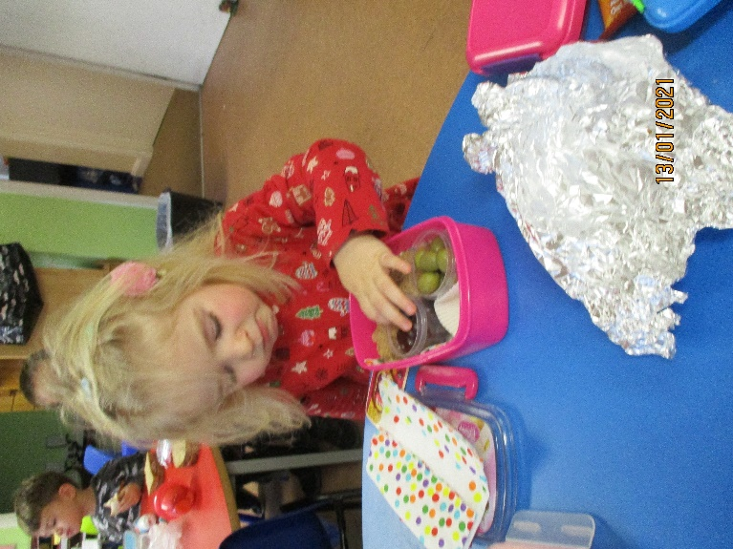The award for a healthy lunch goes to our new starter Natalie. Her lunch box contained lots of fruit as well as olives. Well done!

Lunch time awards are simple stickers that should encourage children to eat healthily. There is no pressure for parents to add food that children may not eat.

**Dates**

**Pyjama Day – 27th January** Please donate £1.

**Half term** – 15.2.21 – 19.2.21

**Parents Consultation evening by phone** – 02.03.21