

**Noah’s Ark Newsletter March 2021**

Dear Parents,

We have had lots of fun recently with our traditional stories themed weeks and have planned a few more as the children seem to be enjoying these. Our selection of topics are firmly based on children’s interest and we will concentrate on those that capture their interest longer.

For the last week of our term, we have planned themes around Easter. To support our fundraising efforts, we will send a shape of an egg home which the children can decorate to their liking. Please sponsor them for their efforts and we will display them in the window and the two most unusual ones will win a price.

We will continue to send pictures and videos of your children via the parents whatsapp group. Please do not worry if you do not always see your child or if they don’t take part as they may not be interested at that time. We can only encourage children to take part, but please be rest assured that they will all be doing something whilst they are here at Noah’s Ark.

Sadly Nicholas Cook is leaving us on the 26th March for a new life in Germany. The children and the team wish him all the best for his start in his new nursery and ‘Viel Glueck’ for his parents in their new environment. We may see them again in 3 years’ time.

Stay well and safe

Happy Easter!

Bettina Campion and all the Team

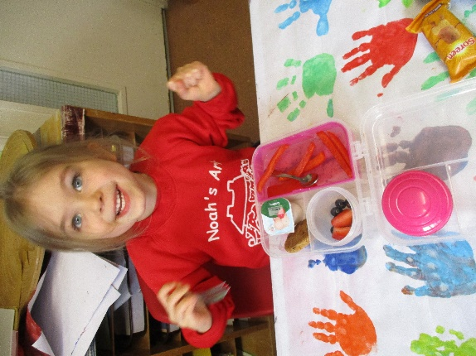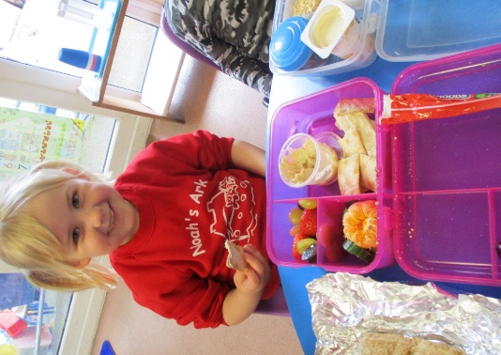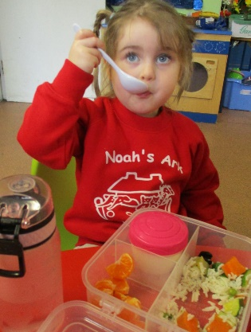

**Lovely lunches!**

**Fundraising News**

Our book character day was very successful and we really enjoyed seeing the children in their costumes. As you know we fundraised for the Parish’s Lenten Project which made **£67.** A super amount. We hope to pass this on to Father Ignatius as soon as possible. ☺☺

We have recently bought some new resources with some fundraising money and the children were delighted with them (letters and numbers building blocks, magnetic construction toys, farm animals, a new children’s microwave and toaster). We will add a tool work bench soon.

**Children’s quotes**

‘**Bettina, you can have some money from my piggy bank’** – Lilliah, when discussing that toys should be looked after as they are expensive.

When Theresa was wearing full PPE for the first time Primrose remarked ‘**she looks creepy**.’

**Fast flow tests etc.**

The DfE has now issued fast flow test for nurseries and all team members have been given a pack. This has to be performed twice a week. Some of us have either already received their vaccination or are due to receive one. We have also been issued with a few more masks which helps to manage the daily tasks. At snack time, when children are being changed and when children are ill, full PPE will be worn. The team member preparing snacks will wear this all day. I have again attached advice for parents to distinguish between possible Covid signs and a common cold.

**Dates**

St. Patrick’s day – tomorrow 17th March – Please wear something green on this day!

Easter egg hunt on **31st March**

Last day of term – 1st April – pre-school finishes at **2.15pm**

First day of summer term - Easter holidays – **02.04.21 – 19.04.21 – pre-school will finish at 2.15pm on 1st April.**