

**Noah’s Ark Newsletter November 2021**

Dear Parents,

A big thank you to all parents and grandparents who joined us on our walk to Alexandra Park. It was lovely to see so many of you on this occasion. Pictures of this walk are now on our website.

You have been handed your child’s Learning Journey if you had your parent meeting this week. Please ensure to return it very soon with some pictures or drawings added from home.

For the remaining weeks we have planned many activities including festive ones. Some of these may be fundraising activities as we have been missing out on those during lockdowns. We are aiming to fundraise for a new tool station.

The children will begin to start rehearsing for our Christmas singing. For this we are hoping to invite parents to watch in the morning and afternoon. We will inform you soon about these arrangements. Please note that the Christmas singing is now planned for Monday 13th December.

Thank you for reading our news!

With kind regards

Bettina Campion

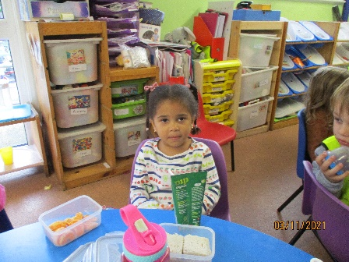

Seraphina’s healthy lunch in November.

Sandwich, oranges and a fruit drink. Well done! ☺

**Team news**

Sadly, Sandie has decided to hand in her notice at the end of the term. She has been a superb colleague, key person and an endless provider of fun activities for the last 10 years. We are sad to see her go, but wish her all the best in the future and hope that her plans to change direction will come to fruition. Her last day will be 13th December 2021.

We will rearrange our team deployment and Sandie’s key children will be distributed to other team members.

**Covid update!!!**

More and more families at Noah’s Ark have or have had Covid. Please make sure you test your child with a lateral flow test before you send them back to school. Children can be carriers and may have mild symptoms, but still look out for a continuous cough and/or fever. Noah’s Ark was closed for 4 weeks last year as we all had Covid at the same time. We would not want to have this happening again and need to protect all at Noah’s Ark. Thank you for your cooperation in this matter.

**Stickers**

Every day we hand out stickers for all sorts of little tasks and good deeds the children have performed. Sometimes the children lose them before the day has ended. Rest assured all children receive a sticker at some point. Occasionally, we will reward with a bigger sticker for some extra effort and we will put this on a sticky label for parents to see. This will be handed out at the end of session.

**Lunch boxes**

Some of the children who stay for lunch have new plastic lunch boxes for their sandwiches and fruit. They are excellent and very hygienic, but the children are struggling to open and close them. Please can you practice with your children at home! Thank you.

**Fundraising**

Helen and Emanuel (Leonardo’s parents) have recently sold Halloween treats and kindly donated all monies received to Noah’s Ark. The amount raised was a fantastic **£285** and has been allocated for additional bikes and construction toys. Please see below picture of Emanuele selling sweets in the rain. ☺☺

Further planned fundraising events include pyjama day, Christmas cards, making a festive picture at home and selling children’s Christmas decorations.

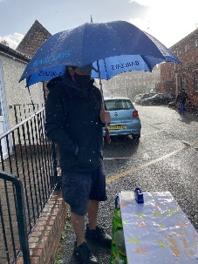

**Social evening**

We are planning a social event for all parents to meet with the team and some committee members on Monday **22nd November at 7.30pm**. There will be drinks and nibbles such as mulled wine and mince pies offered. We will also sell children’s work for a donation. Proceeds of the evening will be allocated to a **new** **art station**.

We hope that many of you can join us on this evening.☺☺

**Dates for your diary**

Parents evenings – week beginning **8th November –** all appointments have been arranged.

Pyjama day – **17th November** – dress up in your pyjamas and the team will do too! Please donate one or two pounds which will be used for new decorations at Christmas.

**Meet everyone at Noah’s Ark** – 22nd November – 7.30pm mulled wine and mince pies will be offered. Details will follow soon.

**Annual General Meeting** (AGM) at Noah’s Ark – 29th November, 7.30pm details will follow soon.

Christmas Singing – **Monday 13th December (am and pm) Details to follow**

Christmas Parties am and pm – **Tuesday 14th December – Please wear your Christmas jumper on this day!**

Last day of term 14th December – **pre-school finishes at 2.30pm**