

**Noah’s Ark Newsletter January 2022**

Dear Parents,

A very warm welcome for our new starters Thomas, Arianna, Joaquin and Marcelina. They are all settling in well into the Noah’s Ark family.



Since September 2021 the EYFS (Early Years Foundation Stage) has changed and we have adapted our curriculum to suit the cohort of children we have and the legal requirements. All seven learning areas will be taught so that children enhance their communication skills, physical wellbeing including dental hygiene, independence and social skills. We do this through well known stories and physical activities such as running, balancing, dancing, yoga etc. All of these activities will help children develop all the required skills in order to be ready for school.

There is now less emphasis on written observations and more on interactions with the children. On this note, we try to use our WhatsApp group only for videos, photos and activity topics for educational purposes only and won’t send videos every day. All other information will be sent via email.

Many thanks for reading our news

With kind regards

Bettina Campion

Healthy lunch of the month!

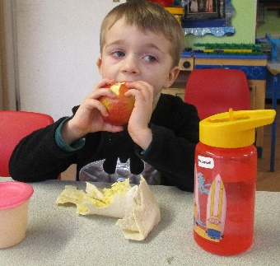







Thomas’s healthy lunch consisting of a wrap, yoghurt, apple and water. Well done! ☺

**Lunch boxes all day children**

Please be reminded that children will bring home uneaten food/packages so that parents are aware of what has been eaten. We also have very limited space for rubbish. If children need support in opening and closing their lunch boxes/food packaging the team will be on hand, but encourage independence at the same time. Please also remember to cut fruit such as grapes to avoid choking hazard. Whilst we will always encourage children to eat their food, we will not force them.

**Covid and illness update!!!**

If your child is unwell please let us know via phone (02083900011) or email (info@noahsark-preschool.org.uk).

If your child receives medication such as antibiotics, our policy is that children need to stay at home for at least 48 hours.

If your child displays any symptoms of Covid, please do a lateral flow test as advised by the DfE and inform us of the outcome. Also, please let us know if you are self-isolating due to Covid.

**Clothes**

Please do label your children’s clothes including Noah’s Ark jumpers, coats, hats and scarves so that they do not get mixed up.

We would suggest to put children in suitable clothing as they are also playing outside and may get dirty whilst painting etc. Please make sure that there are enough spare clothes in your child’s bag.

**Fundraising**

We have had a number of fundraising activities organised by parents, pre-school and the committee during the Autumn term. The fundraising events were Halloween sweets and Christmas candy sale by Helen and Emanuele Orlando, social evening sale of children’s Christmas decorations and Christmas tree challenge by the team and Christmas cards by our chair person Jo Oakley. The total amount raised from September to December was **£1298.50**. ☺☺☺

As previously mentioned, we are now looking at buying a new art and tool station and any other toys/equipment that urgently need changing.

**Dates for your diary**

**Superhero and Princess dress up day** – 3rd February – Pictures will be published on our website.

**Last day of half term** – 11th February – Noah’s Ark returns 21st February

**Parents evenings** – week beginning 28th February **–** all appointments with your key person will be given nearer the time.

**World book day** – 3rd March - dress up in your favourite book character or anything else that you would like to wear on this day. Pictures will be published on our website

**Walk to the station or garden centre or Tolworth park – 25th April –** we will make a decision nearer the time depending on Covid restrictions.