

**Noah’s Ark Newsletter March 2022**

Dear Parents,

We have recently held our parents meetings which were attended by most. A handful of parents will receive their meetings this week. The team received some lovely feedback. We are happy that many parents reported that they appreciate our videos as well as activities based around traditional stories. Group videos may not feature all children and activities as well as involvement are very much guided by children’s interest. Where we can, we will send individual videos directly to parents. Please add your child’s learning from home in their Learning Journey (photos or a drawing) and return it asap. The team is beginning to update the Learning Journey for the next term again.

As we are approaching the Easter holidays, we hope to offer plenty of activities around Easter and look forward to our traditional Easter Egg hunt on 1st April. Children who do not normally attend on a Friday are invited for the event only.

Many thanks for reading our news

With kind regards

Bettina Campion

**Healthy lunches consisting of a variety of fruits and vegetables!**

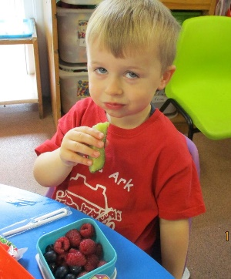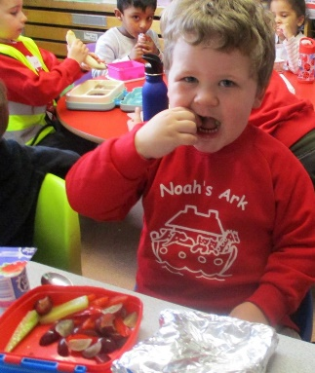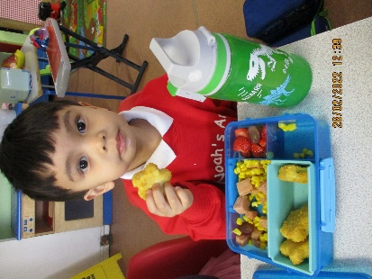

Caelen’s, Harry’s and Isaac’s healthy lunches. Well done! ☺

**Spanish for children**

Recently, the children were given a Spanish taster session. A short video was posted on the parent WhatsApp group of this trial. We would like to hear feedback from parents if they felt that their child would benefit from a regular short lesson once a week for 6 weeks. Unfortunately, we cannot offer two sessions back to back for morning and afternoon group as this does not fit in with our routines or those of the teacher. Please would you let us know via email or on the parent video WhatsApp group whether you would like us to buy 6 weeks of sessions. The children would be taught by a parent who used to have a child here last year.

**Illnesses and Covid**

A few children and team members suffered with Covid recently and subsequently stayed at home for at least 5 days or when they felt much better.

Please do keep testing your children if you suspect Covid. We may not be able to keep Noah’s Ark open if too many children or staff have Covid or any other illnesses. We are only a small team and rely on the team’s flexibility to work on their days off.

If a child is listless, wants to sleep or develops a temperature at pre-school, we will call their parent to collect. Please ensure to be available by phone. Thank you!

If your child is unwell please let us know via phone (02083900011) or email (info@noahsark-preschool.org.uk).

**Volunteer**

We welcome Michelle Kapilan as a student volunteer for her level one course. She will occasionally attend Noah’s Ark. Michelle is DBS checked.

**Fundraising**

World book day raised £75 for the Lenten project. We hope to add one more fundraising event before we hand over the monies to the church.

Thank you for being so generous. ☺☺

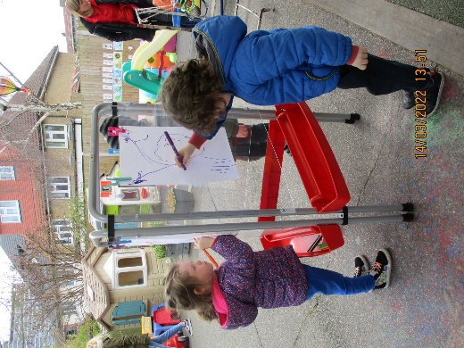Our new art station fundraised by parents of Noah’s Ark.

The children are very happy with their new art station☺

**Dates for your diary**

**Easter Egg hunt – Friday 1st April – am and pm children. Children who do not normally attend will be invited for the event only.**

**Easter holidays: 4th April until 18th April. Noah’s Ark returns on Tuesday 19th April 2022.**

**Walk to the station or Tolworth park – 25th April –** details nearer the time, but we will need parent helpers on this trip.

**Chicks!** – During the month of May. The children will enjoy the hatching of chicks and learn how to look after them.

**Multicultural day 3rd May –** dress up in your cultural clothes

**Sports day** – 24th June