

**Noah’s Ark Newsletter September 2022**

Dear Parents,

A very warm welcome to our pre-school and first newsletter of the academic year.

For the year ahead, we have planned many events some of which are already advertised on our website. Our next important event will be our social evening on 27th September at 7pm. This event is for parents only.

The first term will be spent getting to know your child/ren and helping them feel comfortable and happy in our pre-school environment. Please look out for forthcoming requests of family photographs and other activities. We will inform you of our daily activities on our whatsapp group.

As all of you have been added to our whatsapp group, we will send occasional videos. With these videos we hope to offer you a glimpse of their day at Noah’s Ark under the careful guidance of our team. We appreciate any comments on our videos, but are unable to engage in chats within the group.

I hope that you and your child/ren will enjoy our pre-school activities in the coming year and support all our events in great numbers.

Thank you for reading our news

Bettina Campion

**A healthy lunch with lots of fruit!**

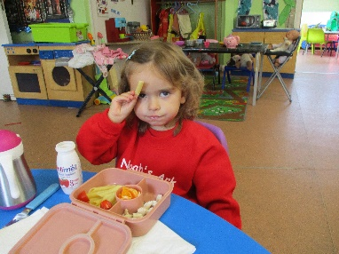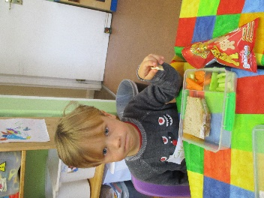

Well done to Gabriela and Nikodem, ☺☺☺

**Key person working days**

Bettina: Mon-Wed and Fri Theresa: Mon-Tues and Thur-Fri

Rosy: Tues to Thur Nevila: Mon to Thur

Lisa: Mon, Wed and Fri Soraia: Mon, Thur-Fri

We are supported by Suelli Loures and Latoya Reisinger who work as bankstaff and learning support assistants. Michelle Kapilan is a level 2 student on Tuesdays.

***Uniform, spare clothes and food***

Please ensure that you label your child’s uniform and spare clothes with their names or even just their initials. Also, please try and keep spare clothes at Noah’s Ark rather than taking it home all the time. Avoid big bags where possible. Our pegs do not have space for bags **and** jackets. Please also bring the red book bag every day to school. This will help build a routine. Thank you!

We are a **nutfree** pre-school so please no peanut butter sandwiches or nut snacks for your child’s lunch. Cakes should be nutfree too! Please also ensure that their fruit is cut up in easily edible portions especially when giving them grapes. Thank you!

***Improvements at Noah’s Ark***

During the summer a large area of our playground was improved with new artificial grass and extra underlay. Not only does it look much brighter, it is also safer for the children.☺ Please see picture below. We hope to get the pre-school painted indoors during the holidays.

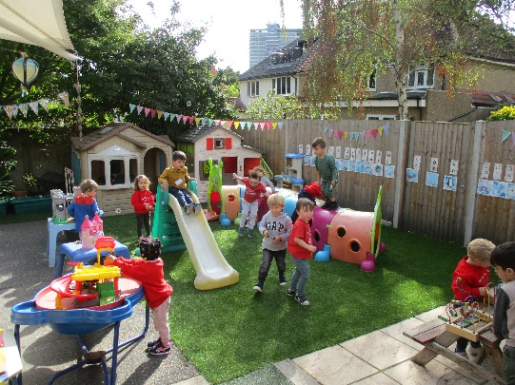

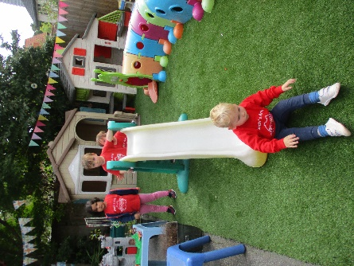

***Stickers and Helping Hands***

We award stickers for kind behaviour and other small achievements. You may have seen your child come home with a helping hand sticker such as the monitor or book bag helper. These small jobs are designed to get children involved and used to our routines as well as being part of our motto ‘being kind and helpful’.

***Pre-school Committee***

Our pre-school is supported by a pre-school committee which means that we can run as a charity. The committee is made up of parents of the pre-school. Our committee chair presently is Jo Oakley who used to have children here. Please look out for committee fundraising events and get involved. All monies raised will be used to purchase bigger resources for the children.

***Dates for your diary***

**Social evening** – 27th September at 7pm, parents only. Nibbles and drinks provided

**Half term holidays**- 24.10 until 28.10.22

**Walk to the park** – 01.11.22, parents needed for supervision

**Parents evenings** – week beginning 8th November

**Pyjama day** – 23.11.22

**Christmas jumper day – 9.12.22**

**Christmas play** – 12th December, details nearer the event.

**Christmas party** for children – 14th December

**Last day of term** – 14th December