

**Noah’s Ark Newsletter November 2022**

Dear Parents,

Thank you to all parents who came to our parents’ evenings in such great numbers. We hope you felt that our feedback was constructive and useful. Our next meetings will be at the beginning of March 2023. Please remember to return their Learning Journey with photo(s) or a drawing added from home. Please use one page only.

We would also like to thank all parents who accompanied us on our traditional walk to the park on 1st November. We really appreciated you taking out time to support this event. Many of the leaves and other items that were collected have now been used in our Autumn themed activities.

As we are entering the busy Christmas period (only 4 weeks left in our half term), we will be practicing Christmas songs and activities with the children. There are also a few fundraising events planned for the coming weeks and we hope you are able to support these despite the present difficult financial times. All monies raised will go towards buying large story books, new smartboard pens, new projector discs and a cd player with microphone.

Thank you for reading our news!

Bettina Campion

**Staff/Student News**

Many congratulations from all of us to Soraia who is expecting a baby at the beginning of March 2023. She will take her maternity leave in the new year. We hope that all will go smoothly for her.

We are saying goodbye to our bank staff Suelli and Latoya who used to work for Noah’s Ark on a permanent basis. They are taking up new positions in another school and nursery. We wish them all the best.

We say hello to our level 2 student Sherry Khan, Mudabbir’s mum, who will learn with us until July 2023. We hope she enjoys her time with the children.

***Uniform/shoes***

There are still plenty of nearly new and clean jumpers available if you need one. Please make sure that you write your child’s name in their jumpers to avoid them coming home with the wrong one.

Please always send in shoes as well if your child is wearing wellies to pre-school. Thank you.

***Fundraising activities***

For this half term we have a few activities planned to help raise funds for our pre-school.

Please support our **Christmas artwork** for the children. Details including your children’s artwork will be sent shortly.

**Christmas clay decorations** will be produced by the children and you will have an opportunity to buy these for a donation.

We are holding a **pyjama day** on 23.11.23 and are asking the children to dress up in their favourite pyjamas in return for a small donation. The team will take part too!

For Christmas we will ask children to get sponsored by family members, friends and neighbours for decorating their **Christmas tree**. All creations will be displayed in the pre-school and the monies raised will be put towards buying the above mentioned resources. The most original ones will win a prize too!

☺ Walk to the Park ☺

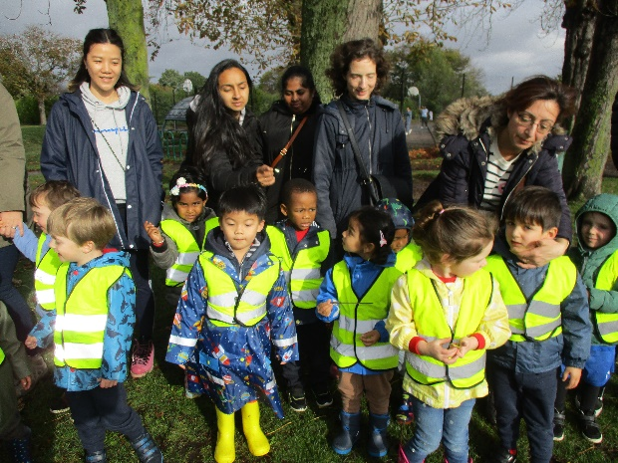

***What is the termly fee of £25 used for?***

The fees are used to help with costs that are not covered by funding received from the Government. For example, we use this to buy items for the twice daily snacks, Christmas presents for the children, Christmas party food and drink for the children, extra-curricular activities such as Spanish lessons, living eggs to name but a few. There are many more. All the monies received from the termly fees are used entirely for children’s activities and well-being.

***Pre-school Committee – Annual General Meeting (AGM)***

# Our pre-school is supported by a pre-school committee. Our committee chair Jo Oakley has arranged for our Annual General Meeting to take place on Monday 28th November at 7.30pm. We will be reflecting and reporting on the past year’s events and our financial position. Please support our committee and come along. We need new members for our committee as some parents, who now have children at Primary school, are stepping down. Drinks and nibbles will be provided for the meeting.

***Dates for your diary***

**Pyjama day** – 23.11.22 – dress up in your favourite pyjamas, donation please (£1 or £2)

**Annual General Meeting (AGM)** – 28th November at 7.30pm, drinks and nibbles provided.

**Christmas jumper day – 9.12.22** wear your favourite Christmas jumper on this day.

**Christmas play** – 12th December at 10.30am, details nearer the event.

**Christmas party – 13th Christmas party** for children in the afternoon and **14th December** in the morning**.**

**Last day of term** – **14th December,** pre-school finishes at 2.30pm

**First day of Spring term** – 3rd January 2023

**Last day for Primary School applications** – **15th January 2023**