

**Noah’s Ark Newsletter February 2024**

Dear Parents,

I trust that you are all keeping well!

It is nearly half term week and I hope that you will get some well-deserved rest with your children.

In our recent fundraising events we made £344. So far we have spent £109 on a wooden dolls house. Please see picture below. The remaining money of £235 will be added to the money from our dress up day. We will hold one more event for Easter and then buy the new caterpillar after we return from our Easter holidays.

Please look out for our forthcoming Annual General Meeting (AGM) – dates and times will soon be advised by our chairperson Ruth Antoniades (Nevaeh’s mum). All are welcome.

Thank you for reading our news.

Kind regards

Bettina Campion

**Healthy lunches**

January and February winners are Jude and Arthur ☺☺ who regularly have a very healthy lunch with lots of fruit or vegetables. Reward stickers for healthy lunches will appear in their Learning Journey.

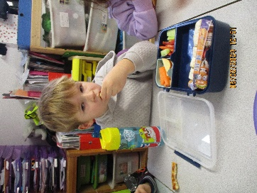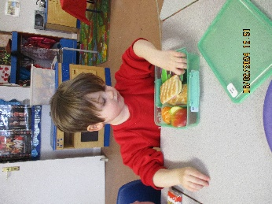

**Working towards HEYL (Healthy Early Years London) Bronze award**

The team is working towards the HEYL Bronze award. In the next few weeks you will receive some information on healthy foods and what we offer at Noah’s Ark as well as some information on toilet training and looking after their teeth. We hope to complement what you already do at home and wish to work in partnership if you need support in some aspects.

**Spare clothes/clothes bags**

We have invested in some new clothes bags for the children. These bags ensure that there is sufficient space on their peg for their jackets. Please can you replenish or even bring in change of clothing for your child. Clothes can get wet or dirty during activities and many children of this age may still have accidents. Thank you for your cooperation.☺

**Fundraising Heroes and Princesses Day**

As we are still fundraising for a caterpillar outside, we have used the donations received for our dressing up day towards a replacement. We have made a whopping £75.

Thank you for supporting our event, we really appreciate your generosity.☺☺☺

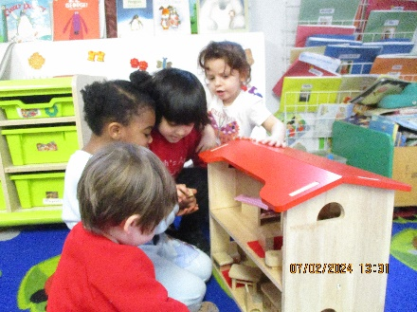

***Pre-school Places***

*We still have some free places in the am/pm sessions as well as all day. If you know anyone who is looking for a pre-school place for their child for now or in September 2024, please recommend our lovely pre-school to them. We offer a nurturing environment with fun and educational activities for ages 2-4 under the guidance of experienced, well qualified and warm pre-school teachers.*

***Parents’ Consultation Days***

Please make a note in your diary for the upcoming consultation days. Appointments will be offered on your key person’s work day with the first appointment at 3.40pm. They should not last more than 10 minutes and your key person will talk about their learning achievements and hand over the Learning Journey for you to add something from home and return them to us as soon as possible.

***Dates for your diary***

**Half term** 12.2. to 16.2.24. Noah’s Ark reopens 19.2.24

Parents’ consultations – week beginning 26th February. Timings will be offered the week before and displayed on the door.

**Annual General Meeting (AGM**) – March, exact date to be advised.

**Easter Egg hunt** (am and pm) – Thursday 28th March 2024

**Last day of term** – 28th March 2024– we finish at 2.30pm