

**Noah’s Ark Newsletter June 2024**

Dear Parents,

We are nearing the end of the academic term with less than 5 weeks left. There are still so many things planned for the children and we hope that we will make their last few weeks here very enjoyable. The team are presently preparing Learning Journeys and reports for the pre-school leavers and those who are staying on for another year. They will be handed out at the beginning of July.

We hope that you can all join us for the next few events to create some lasting memories for all to enjoy. Please see below for details of these events.

Next week is our **Sports Day**. All are welcome to join in with the fun. This event should not take longer than 45 minutes. It is also weather dependent and we may have to cancel on short notice. The children will need to wear suitable shoes such as trainers. We hope to see you all in great numbers on the 18th June at 9.30am!

Thank you for reading our news.

Kind regards

Bettina Campion

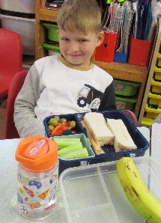

**Arthur had a healthy lunch throughout the year! Well done, Arthur☺☺☺**

**Working towards HEYL (Healthy Early Years London) Bronze award**

We have submitted our application and are awaiting the Bronze award within the next few weeks. Since starting the audit, we have made some changes to our snack time, for example we are no longer offering raisins as a snack. Raisins may cause tooth decay as they tend to stick to children’s teeth.

***Dance performance/last day of term picnic***

On **Tuesday 9th July at 9.30am**, the children will perform some dance routines they have learned in front of their parents. This event is mainly for children who will leave the pre-school for primary school.

To say goodbye to all children and parents, we are inviting everyone for a picnic at Noah’s Ark Pre-school on **12th July from 1pm until 2.30pm.** If you can, please bring a favourite dish of yours that you may be able to share with everyone at Noah’s Ark. If it is raining we will hold the picnic indoors.

***Kingston Children Centres***

The summer programme for Kingston Children’s Centres can be accessed through the following link  <https://tinyurl.com/KCCsSummer2024>

***Fundraising***

We have now received our brand new caterpillar☺. It is smaller, but it now allows us to use the green area for other activities and toys. There is still a little money left as we bought one that was on offer. We will invest in new tools for the children as well as some push chairs for the dolls.

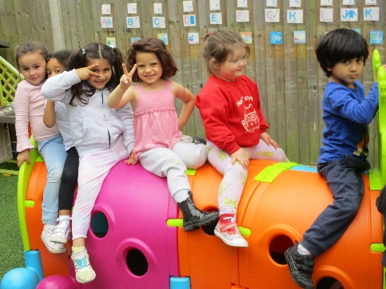

***Dates for your diary***

**Sports Day –** 18th June 2024 at 9.30 am.

**Walk to Tolworth Nature Park** – 2nd July at 9.15– morning walk with parent helpers – all welcome.

**Dance Production** – 9th July at 9.30 morning for school leavers only.

**Last day of term** – 12th July, picnic at 1pm in the pre-school’s playground or inside if raining – all welcome.

The pre-school finishes earlier on this day at 2.30pm.

**Noah’s Ark reopens** on 3rd September at the normal times.